STEM

Challenge support materials

p2: Challenge/Questions card

p3-4: Posters

p5: Practitioner notes

p6-8: Word cards (for display or as flash cards)

p9-11: ‘What did we do?’ sheets (for writing, drawing, or adding a photograph)

p12-14: ‘My experiment’ sheets (for writing, drawing, or adding a photograph)

**Make something melt**

**This pack includes…**

© 2022 Little Owls Resources

© 2022 Little Owls Resources

STEM

Can you…

…make something melt?

Challenge

© 2022 Little Owls Resources

STEM

Questions

How would you melt an ice cube?

How would you melt a piece of chocolate?

What is happening as it melts?

?

?

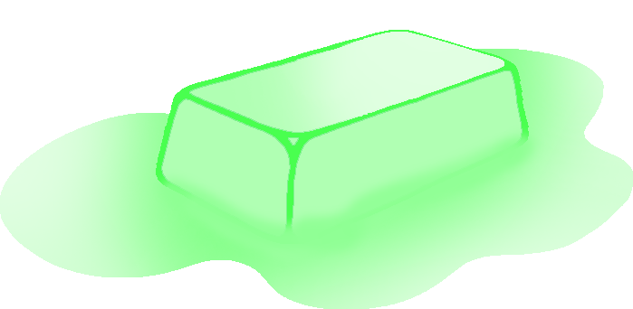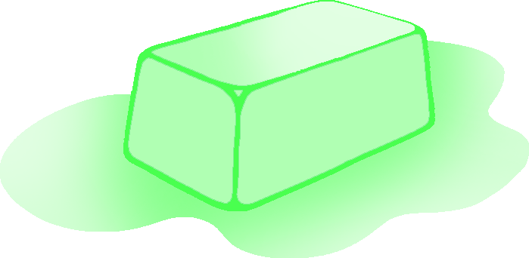

?

melt

melting

© 2022 Little Owls Resources

solid

liquid

© 2022 Little Owls Resources

solid

liquid

Encourage a short discussion about melting.

What have you seen melt before? – Can you melt *anything*?

Give the children time to explore their ideas and show them the suitable substances you have for melting.

How will you melt it? - What do you need to do?

Allow the children to experiment with the substances with as much independence as possible. Let them discover what works and doesn’t work.

How did you melt your item?

How could you have melted it quicker?

* Ice cubes
* Chocolate buttons
* Ice cream
* Butter

**Items that might be useful**

Practitioner notes

**Make something melt**

STEM

© 2022 Little Owls Resources

hard

solid

ice

© 2022 Little Owls Resources

© 2022 Little Owls Resources

© 2022 Little Owls Resources

freeze

frozen

change

© 2022 Little Owls Resources

© 2022 Little Owls Resources

© 2022 Little Owls Resources

drip

melt

liquid

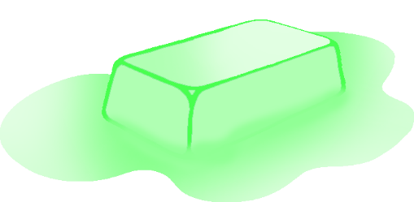

© 2022 Little Owls Resources

© 2022 Little Owls Resources

© 2022 Little Owls Resources

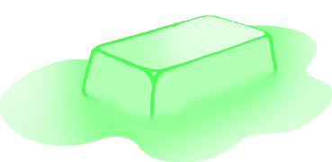

What did we do?

__________________________________________________________________

© 2022 Little Owls Resources

What did we do?

____________________________

© 2022 Little Owls Resources

What did we do?

© 2022 Little Owls Resources

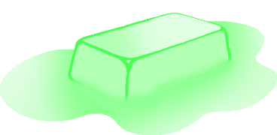

My experiment

__________________________________________________________________

© 2022 Little Owls Resources

My experiment

____________________________

© 2022 Little Owls Resources

My experiment

© 2022 Little Owls Resources