STEM

Challenge cards (sample)

Fold along this line and laminate

These cards are to be used as prompts for a STEM session.

(Science Technology Engineering and Mathematics)

The challenges are intended to be open ended and non-specific to encourage independent thinking in the children.

© 2022 Little Owls Resources

© 2022 Little Owls Resources

STEM

Can you…

…make a shadow?

Challenge

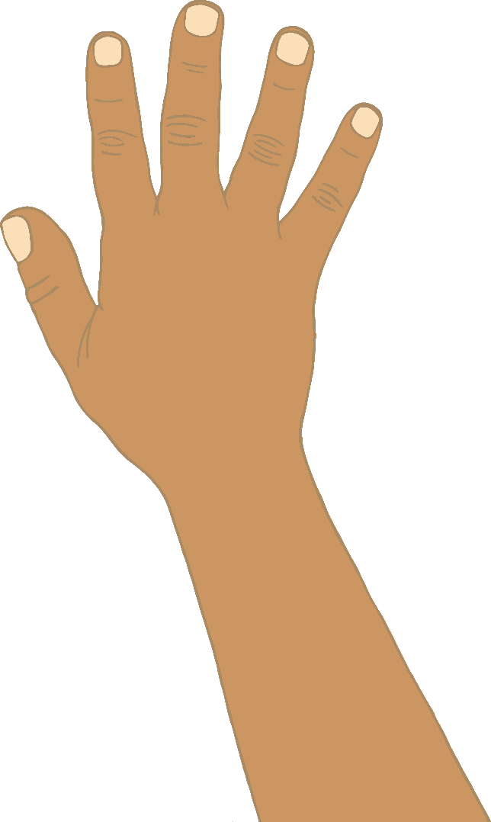

© 2022 Little Owls Resources

STEM

Questions

Can you make the shadow bigger?

Can you make the shadow smaller?

Can you make different shadow shapes?

What happens when you move the light?

?

?

?

© 2022 Little Owls Resources

STEM

Can you…

…investigate minibeasts outdoors?

Challenge

© 2022 Little Owls Resources

STEM

Questions

Can you find a minibeast?

How many legs does it have?

What is the minibeast doing?

How is it different from other minibeasts?

?

?

?

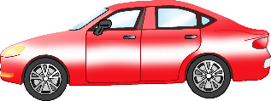

© 2022 Little Owls Resources

STEM

Can you…

…build a ramp for toy cars (to go down safely)?

Challenge

© 2022 Little Owls Resources

STEM

Questions

What happens if the ramp is a steeper slope?

What happens if the ramp is a gentler slope?

Does the type of car make a difference?

Why does the car move?

?

?

?

© 2022 Little Owls Resources

STEM

Can you…

Challenge

© 2022 Little Owls Resources

STEM

Questions

?

?

?