Round and round the garden

© 2019 Little Owls Resources

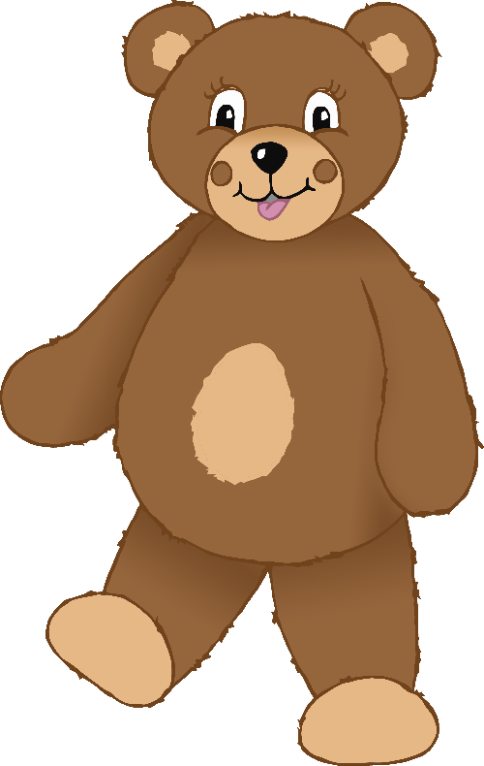

Round and round the garden,

like a teddy bear,

one step, two step,

tickle you under there.

Round and round the garden

© 2019 Little Owls Resources



Round and round the garden,

like a teddy bear,

one step, two step,

tickle you under there.

Round and round the garden

© 2019 Little Owls Resources



Round and round the garden,

like a teddy bear,

one step, two step,

tickle you under there.

Round and round the garden

© 2019 Little Owls Resources



Round and round the garden,

like a teddy bear,

one step, two step,

tickle you under there.