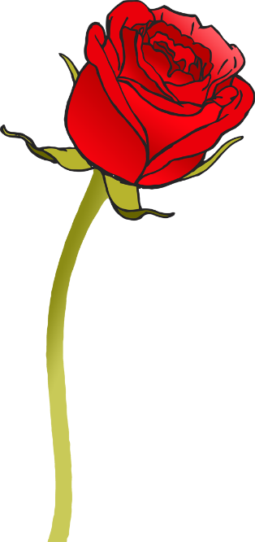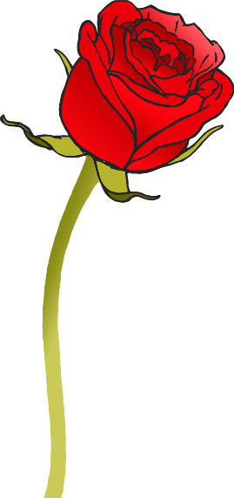

this

© 2020 Little Owls Resources

**w**ill

© 2020 Little Owls Resources

then

© 2020 Little Owls Resources

that

© 2020 Little Owls Resources



look

© 2020 Little Owls Resources

now

© 2020 Little Owls Resources

too

© 2020 Little Owls Resources

do**w**n

© 2020 Little Owls Resources



see

© 2020 Little Owls Resources

them

© 2020 Little Owls Resources

for

© 2020 Little Owls Resources

**w**ith

© 2020 Little Owls Resources



**w**e

© 2020 Little Owls Resources

he

© 2020 Little Owls Resources

me

© 2020 Little Owls Resources

she

© 2020 Little Owls Resources



you

© 2020 Little Owls Resources

be

© 2020 Little Owls Resources

they

© 2020 Little Owls Resources

**w**as

© 2020 Little Owls Resources



my

© 2020 Little Owls Resources

all

© 2020 Little Owls Resources

her

© 2020 Little Owls Resources

are

© 2020 Little Owls Resources