Rocket Shape/Number/Memory game

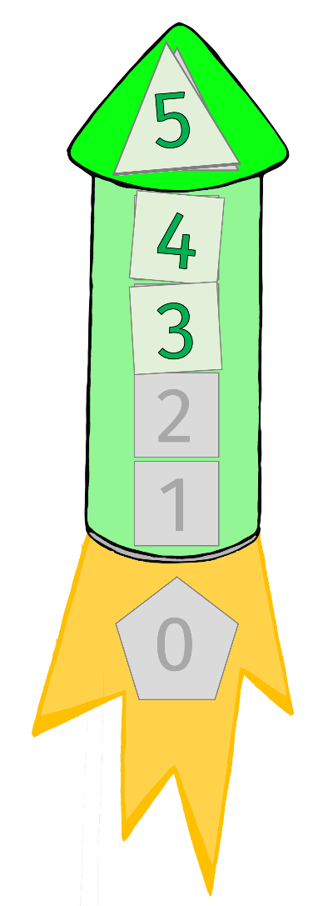
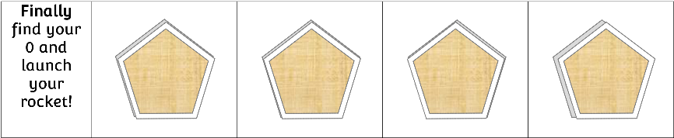
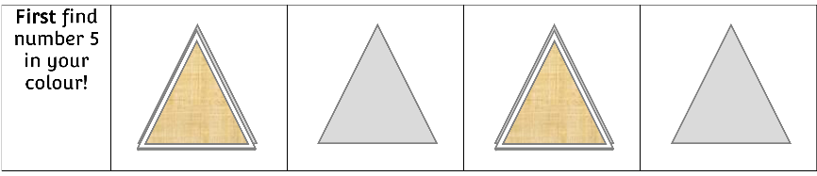
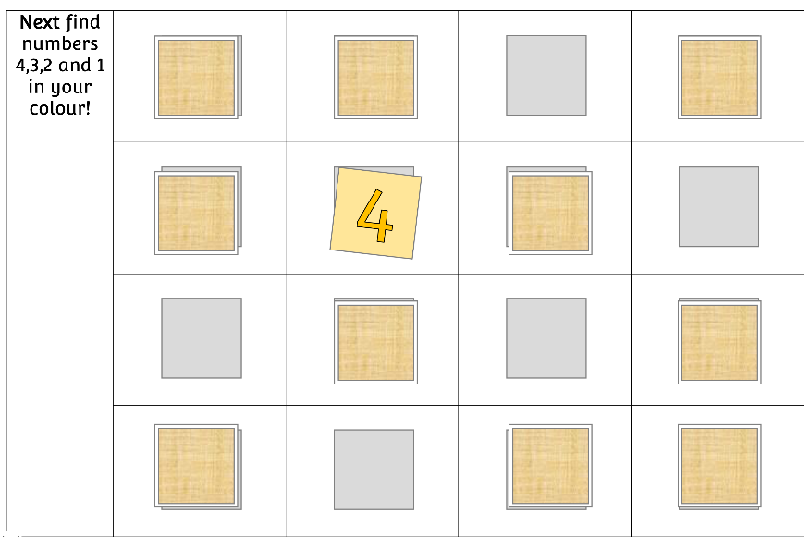
www.littleowls-premium.com
- First take turns turning over a triangle to find the correct colour 5 to correspond with your rocket colour. If not the correct colour, turn back over.
- Then take it in turns to turn over the squares to find numbers 4,3,2,1 in the correct colour for your rocket.
- Finally find the correct 0 from the pentagons to win the game!
2-4 Players
- Cut, fold and laminate the shape/number cards.
- Place them on the grey outline board.
- Each player to have a different colour rocket.

First find number 5 in your colour! |  |  |  | © 2019 Little Owls Resources

Next find numbers 4,3,2 and 1 in your colour!
© 2019 Little Owls Resources

Finally find your 0 and launch your rocket!

© 2019 Little Owls Resources

5
5
5
5
© 2019 Little Owls Resources

© 2019 Little Owls Resources

© 2019 Little Owls Resources

© 2019 Little Owls Resources

© 2019 Little Owls Resources

© 2019 Little Owls Resources

© 2019 Little Owls Resources

© 2019 Little Owls Resources

0
0
0
0
© 2019 Little Owls Resources

© 2019 Little Owls Resources

© 2019 Little Owls Resources

© 2019 Little Owls Resources

© 2019 Little Owls Resources

© 2019 Little Owls Resources

© 2019 Little Owls Resources

© 2019 Little Owls Resources

© 2019 Little Owls Resources

© 2019 Little Owls Resources

© 2019 Little Owls Resources

© 2019 Little Owls Resources

© 2019 Little Owls Resources

© 2019 Little Owls Resources

© 2019 Little Owls Resources

© 2019 Little Owls Resources

4
3
2
1
4
3
2
1
1
2
3
4
2
1
4
3

© 2019 Little Owls Resources

5
4
3
2
1
0
© 2019 Little Owls Resources

5
4
3
2
1
0
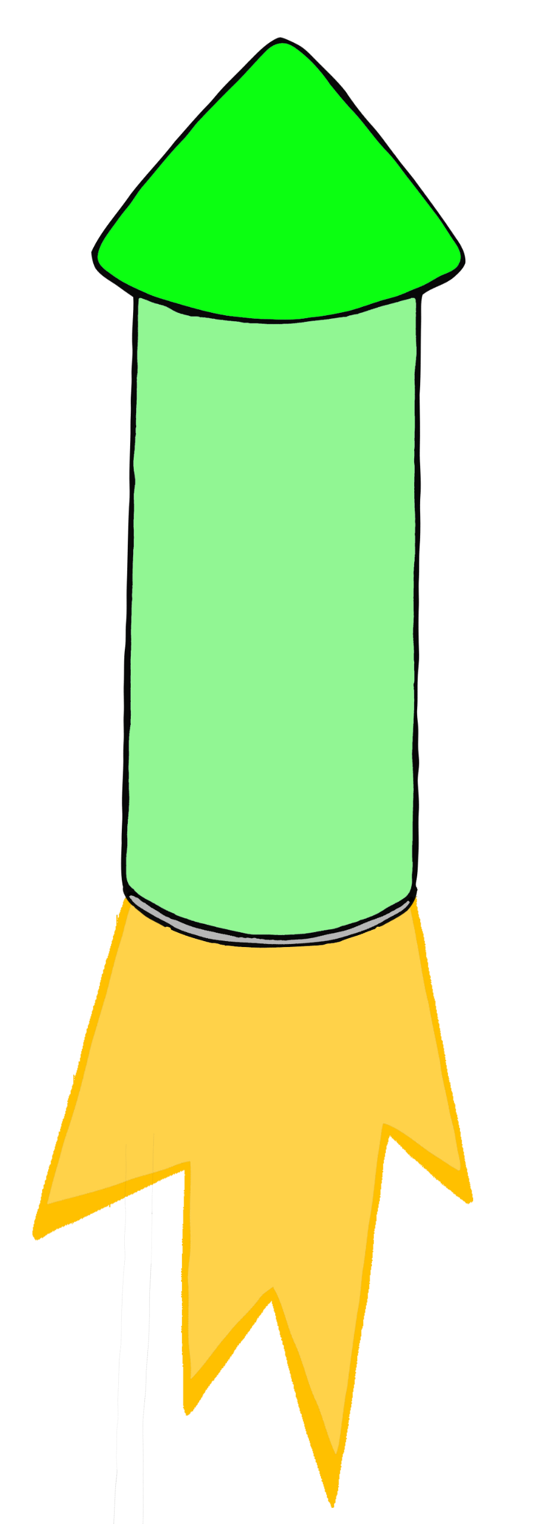
© 2019 Little Owls Resources

5
4
3
2
1
0
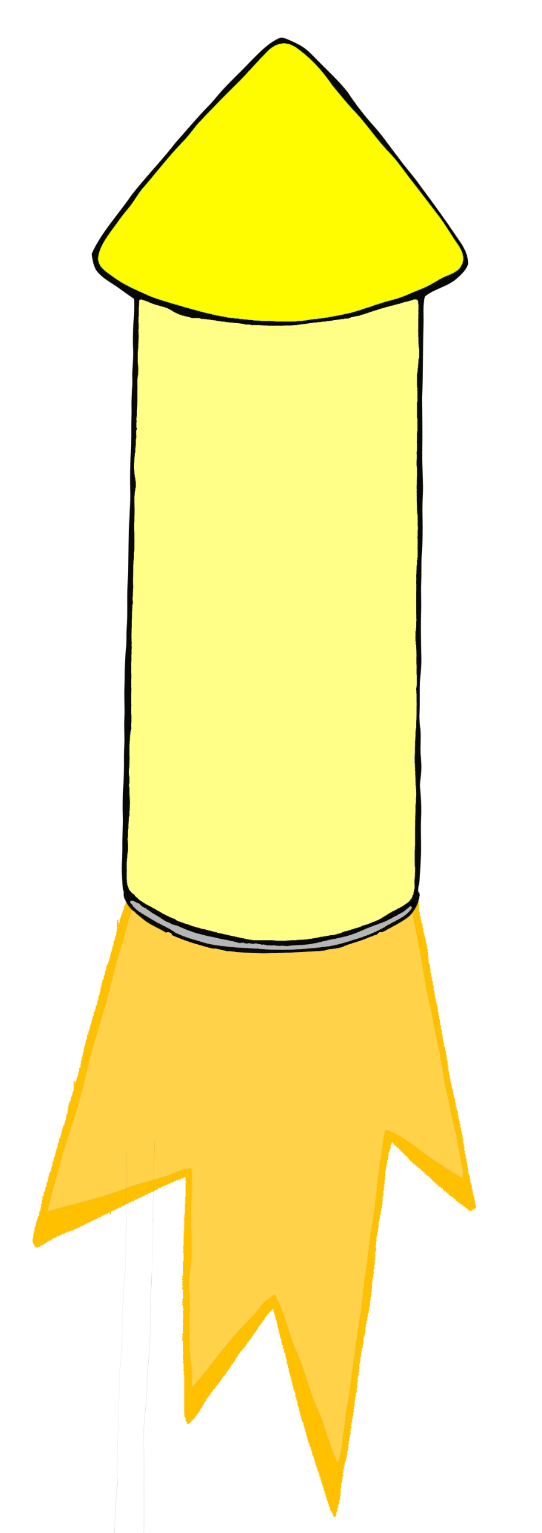
© 2019 Little Owls Resources

5
4
3
2
1
0

