© 2020 Little Owls Resources

**Help the robin get to the birdfeeder!**

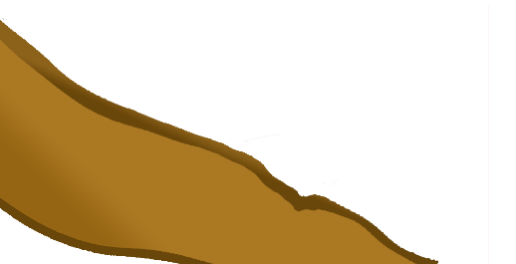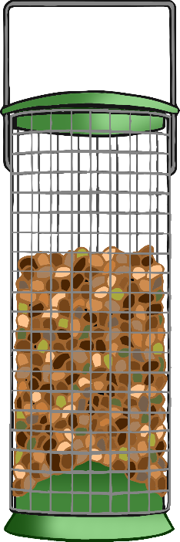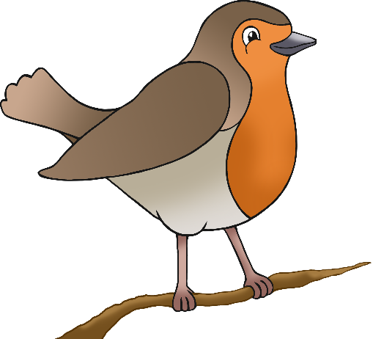

© 2020 Little Owls Resources

**Help the robin get to the birdfeeder!**



© 2020 Little Owls Resources

**Help the robin get to the birdfeeder!**



© 2020 Little Owls Resources

**Help the robin get to the birdfeeder!**

