**Help the robins get to the birdfeeders!** (1)

© 2020 Little Owls Resources

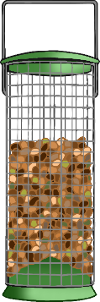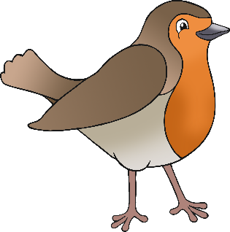

**Help the robins get to the birdfeeders!** (2)

© 2020 Little Owls Resources

