**Robin body parts**

© 2021 Little Owls Resources

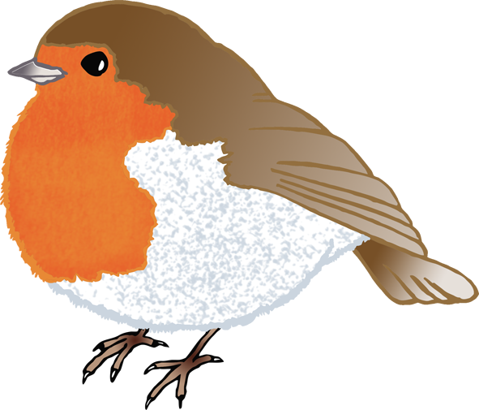

**Robin body parts**

© 2021 Little Owls Resources



**w**

h

b

t

f

**Robin body parts**

© 2021 Little Owls Resources



tail

foot

head

**w**ing

beak