car

police car

ambulance

© 2020 Little Owls Resources

© 2020 Little Owls Resources

© 2020 Little Owls Resources

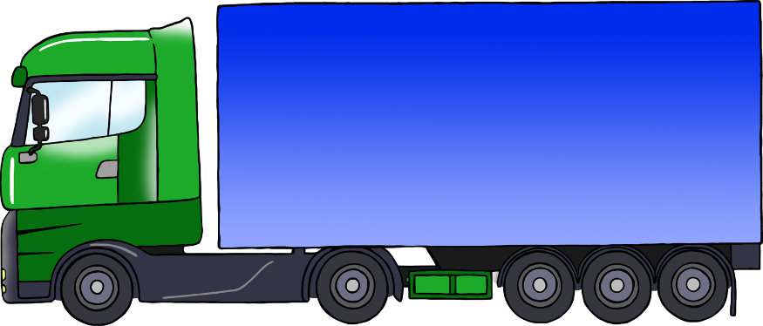

bus

lorry

motorbike

© 2020 Little Owls Resources

© 2020 Little Owls Resources

© 2020 Little Owls Resources

crossing button

don’t walk

walk

© 2020 Little Owls Resources

© 2020 Little Owls Resources

© 2020 Little Owls Resources

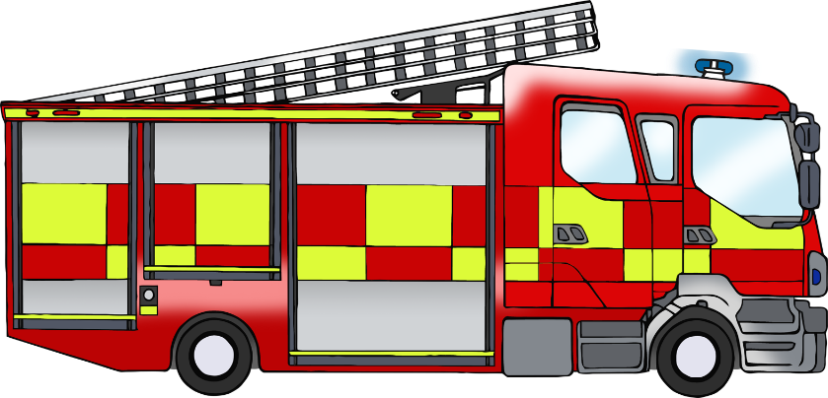

fire engine

cone

bicycle

© 2020 Little Owls Resources

© 2020 Little Owls Resources

© 2020 Little Owls Resources

Car

Police Car

Ambulance

© 2020 Little Owls Resources

© 2020 Little Owls Resources

© 2020 Little Owls Resources

Bus

Lorry

Motorbike

© 2020 Little Owls Resources

© 2020 Little Owls Resources

© 2020 Little Owls Resources

Crossing Button

Walk

Don’t Walk

© 2020 Little Owls Resources

© 2020 Little Owls Resources

© 2020 Little Owls Resources

Cone

Bicycle

Fire Engine

© 2020 Little Owls Resources

© 2020 Little Owls Resources

© 2020 Little Owls Resources