**Road Safety Word Mat**

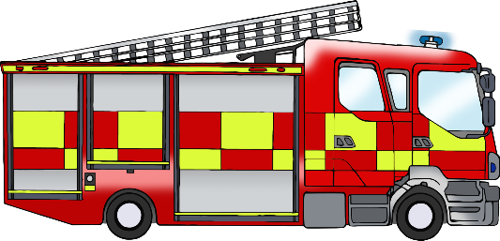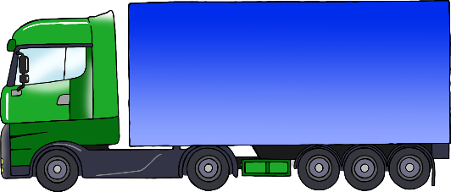

cone

fire engine

lorry

motorbike

walk

crossing button

bus

don’t walk

car

ambulance

police car

bicycle

© 2020 Little Owls Resources