**Road Safety Checklist** ✔️✔️✔️

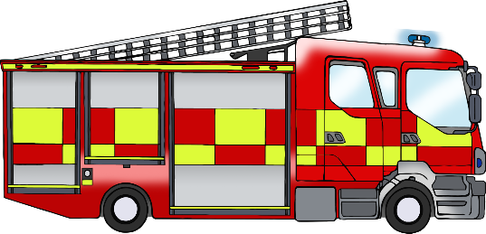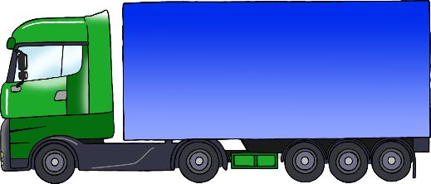

© 2020 Little Owls Resources

**Road Safety Checklist** ✔️✔️✔️

leaves

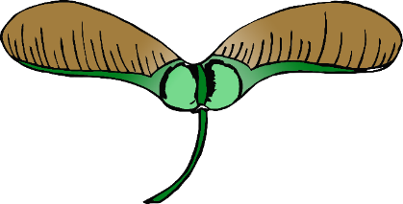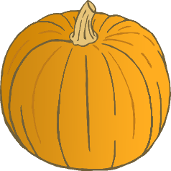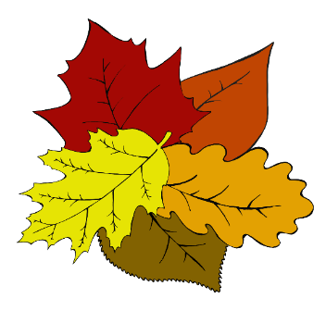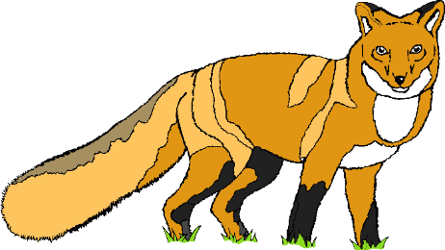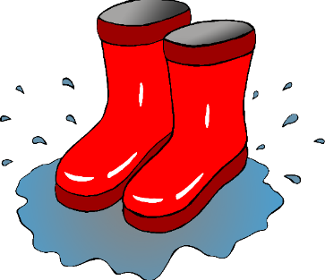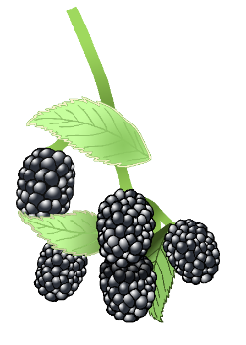

lorry

don’t walk

walk

crossing button

ambulance

bus

cone

motorbike

bicycle

fire engine

police car

car

© 2020 Little Owls Resources

conker

sycamore seeds

pumpkin

fox

acorn

hedgehog

squirrel

rake

fungus

blackberries

wellies