There was once a girl called Little Red Riding Hood. One day she asked her mother if she could visit her grandma in the forest.

© 2022 Little Owls Resources

Little Red Riding Hood held a basket of food as she started her walk through the forest to grandma’s cottage.

© 2022 Little Owls Resources

A wolf appeared beside Little Red Riding Hood. “Where are you walking to? “he asked.

“I am going to my grandma’s cottage in the forest.” She replied.

© 2022 Little Owls Resources

As she continued along the path, the wolf took a shortcut to get to the cottage first.

When the wolf arrived, he gobbled up grandma in one gulp!

© 2022 Little Owls Resources

At grandma’s cottage, Little Red Riding Hood noticed that grandma looked a bit different.

© 2022 Little Owls Resources

“Grandma, what big eyes you have!”

*“All the better to see you with my dear!”*

“Grandma, what big teeth you have!”

*“All the better to EAT you with my dear!!”*

“Grandma, what big ears you have!”

*“All the better to hear you with my dear!”*

© 2022 Little Owls Resources

A woodcutter came running to help. After rescuing grandma, he took the wolf deep into the forest; far away from anyone.

© 2022 Little Owls Resources

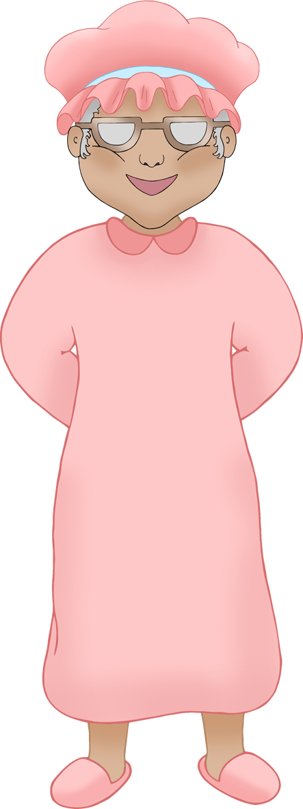

Little Red Riding Hood was so happy to see her grandma was safe! They sat down and enjoyed the food that Little Red Riding Hood had brought.

© 2022 Little Owls Resources

