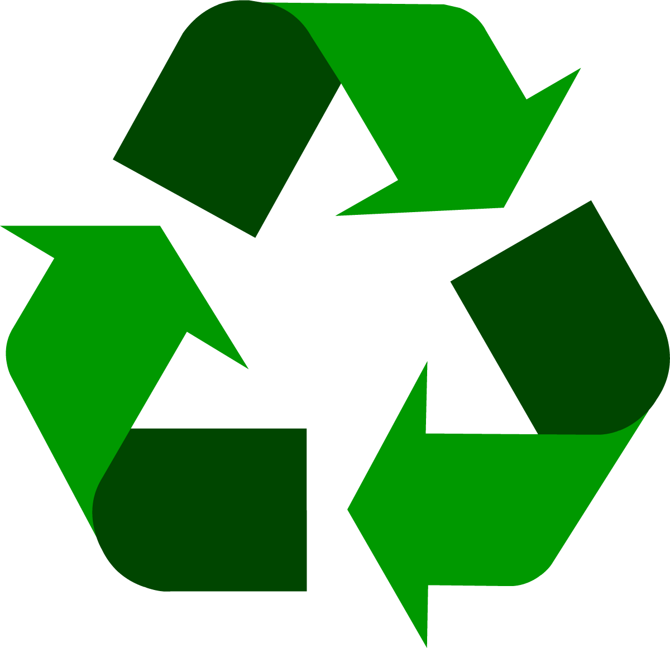

**Plastic**

water bottle

© 2021 Little Owls Resources



**Plastic**

milk container

© 2021 Little Owls Resources



**Plastic**

margarine tub

© 2021 Little Owls Resources



**Paper** / **Card**

cardboard box

© 2021 Little Owls Resources



**Paper** / **Card**

greeting card

© 2021 Little Owls Resources



**Plastic**

yoghurt pot

© 2021 Little Owls Resources



**Paper** / **Card**

envelope

© 2021 Little Owls Resources

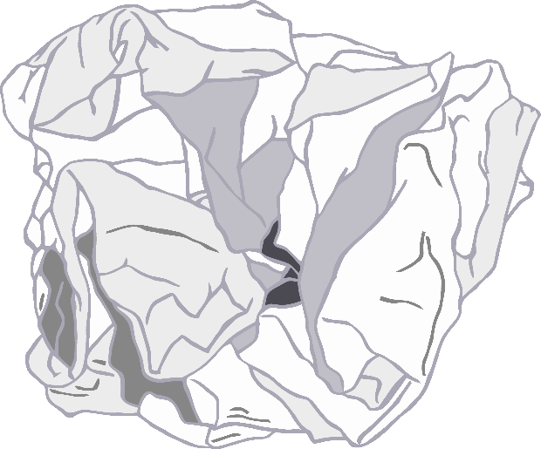



**Metal**

food tin (small)

© 2021 Little Owls Resources



**Paper** / **Card**

crumpled paper

© 2021 Little Owls Resources



**Metal**

food tin

© 2021 Little Owls Resources

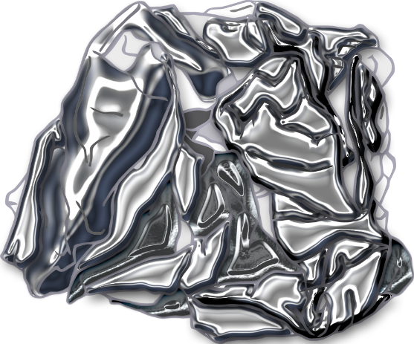



**Metal**

aluminium foil

© 2021 Little Owls Resources



**Metal**

drink can

© 2021 Little Owls Resources



**Food Waste**

carrot

© 2021 Little Owls Resources



**Food Waste**

bread

© 2021 Little Owls Resources



**Food Waste**

fish

© 2021 Little Owls Resources



**Food Waste**

apple

© 2021 Little Owls Resources



**Garden Waste**

brown leaf

© 2021 Little Owls Resources



**Garden Waste**

twig

© 2021 Little Owls Resources

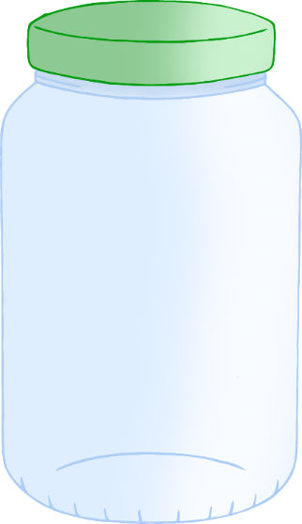



**Glass**

jar

© 2021 Little Owls Resources



**Garden Waste**

green leaf

© 2021 Little Owls Resources



**Garden Waste**

flower

© 2021 Little Owls Resources



**Glass**

green bottle

© 2021 Little Owls Resources



**Glass**

cola bottle

© 2021 Little Owls Resources



**Glass**

brown bottle

© 2021 Little Owls Resources