Recycling

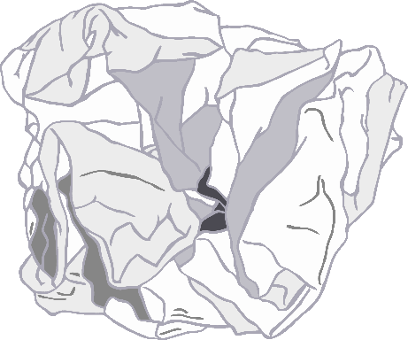

Centre

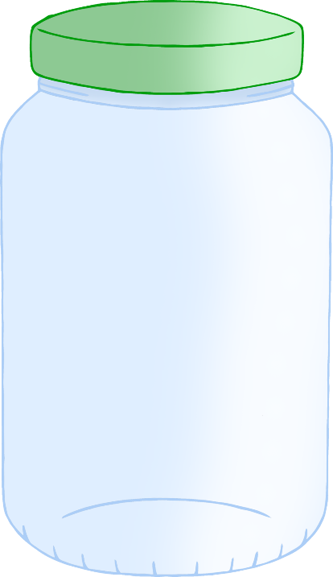

© 2021 Little Owls Resources

© 2021 Little Owls Resources

**Metal**

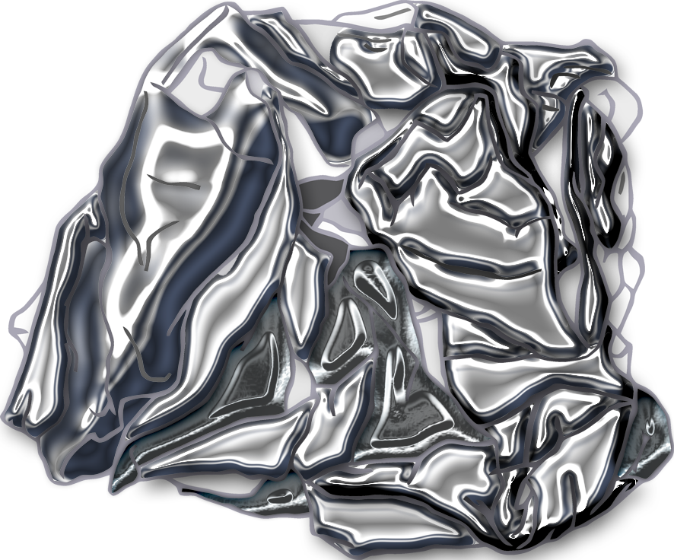

**Plastic**

© 2021 Little Owls Resources

**Food Waste**

© 2021 Little Owls Resources

**Garden Waste**

© 2021 Little Owls Resources

**Paper** / **Card**

© 2021 Little Owls Resources

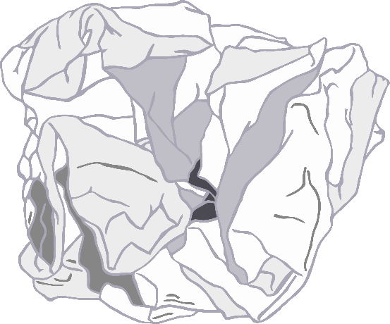

**Glass**

© 2021 Little Owls Resources

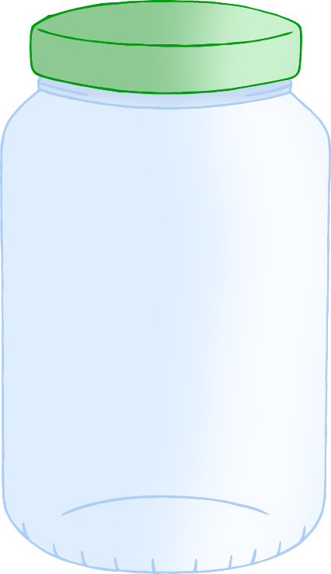

© 2021 Little Owls Resources

© 2021 Little Owls Resources

© 2021 Little Owls Resources

© 2021 Little Owls Resources

© 2021 Little Owls Resources

© 2021 Little Owls Resources

© 2021 Little Owls Resources

© 2021 Little Owls Resources

**Attendant**

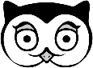

© 2021 Little Owls Resources

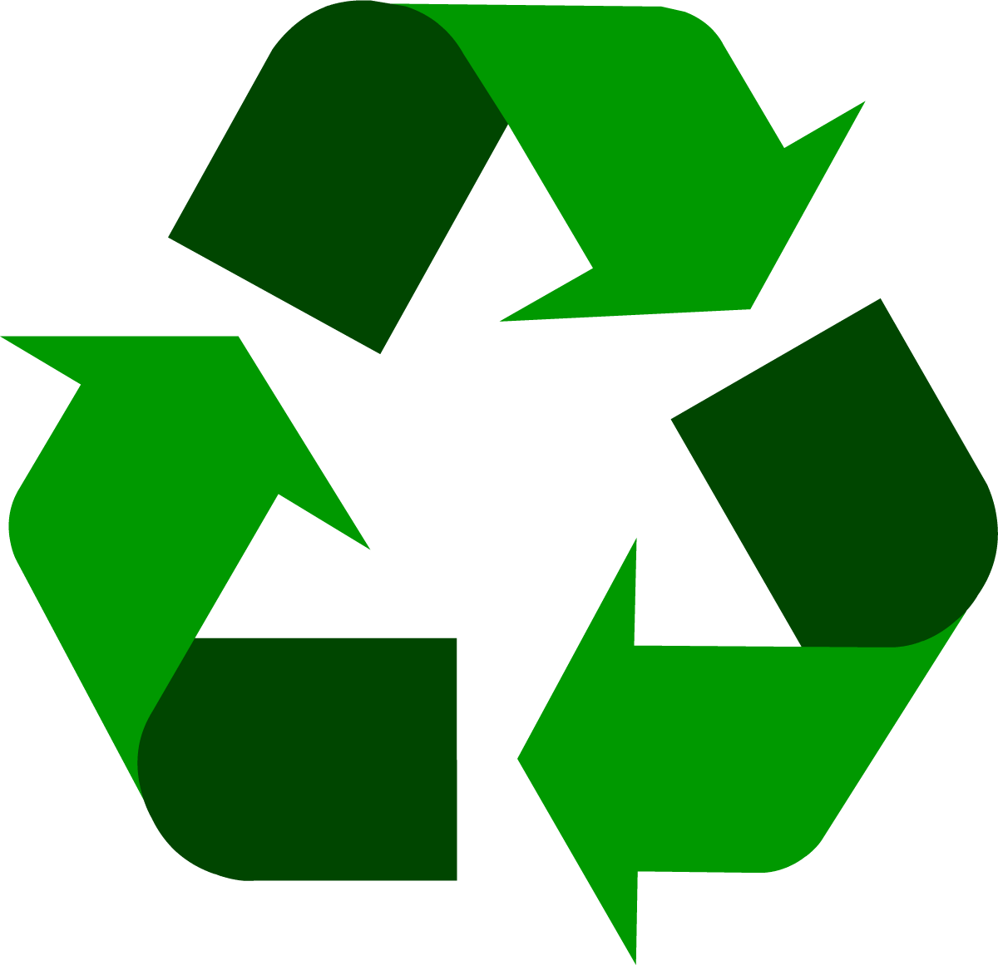

**Attendant**



© 2021 Little Owls Resources



**Attendant**



© 2021 Little Owls Resources



**Attendant**



© 2021 Little Owls Resources



**Not too close!**

© 2021 Little Owls Resources

**

**Thank-you!**

**?**

Please ask an **Attendant**.

Not sure where your items go?...

© 2021 Little Owls Resources

© 2021 Little Owls Resources

© 2021 Little Owls Resources

**Please Wait**

**Recycling Centre**

Please place your items in the correct place.

© 2021 Little Owls Resources

**Open**

© 2021 Little Owls Resources

© 2021 Little Owls Resources

**Closed**

|  |  |
| --- | --- |
| Monday |  |
| Tuesday |  |
| Wednesday |  |
| Thursday |  |
| Friday |  |
| Saturday |  |
| Sunday |  |

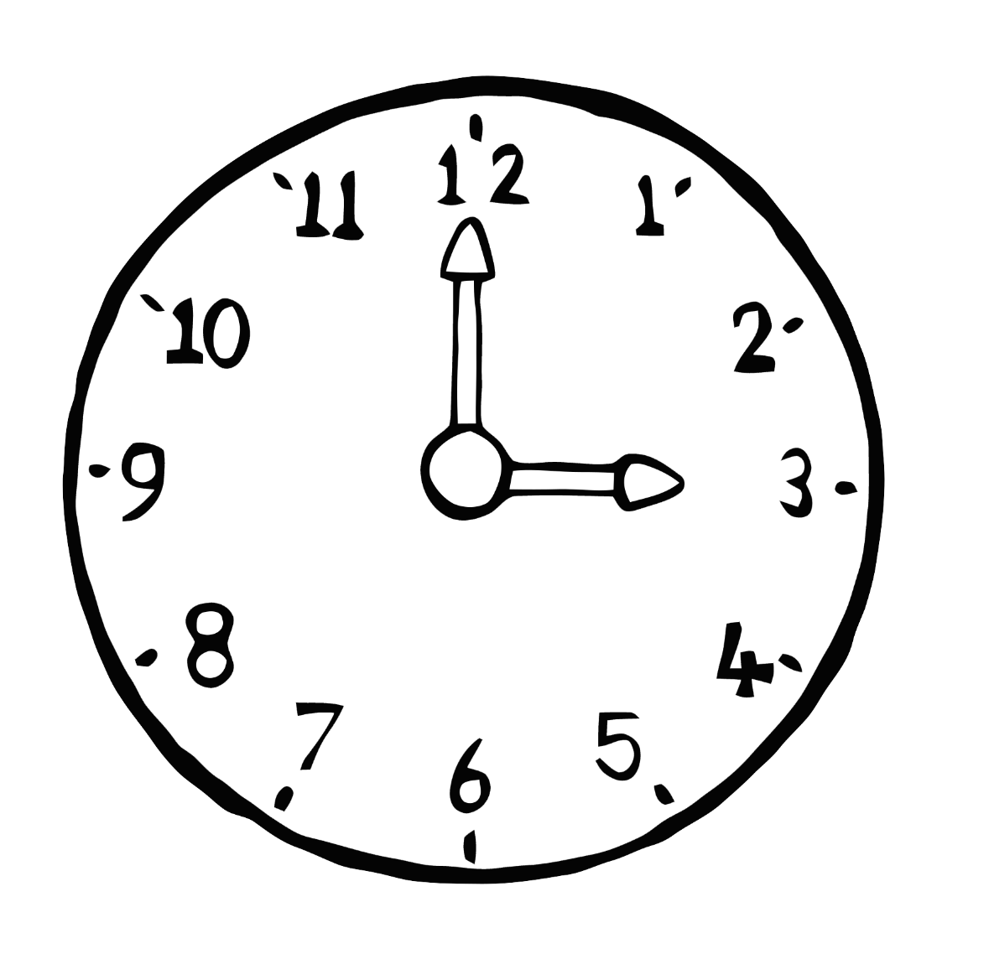

**Recycling Centre Opening Times**

12

8

7

1

5

4

2

10

11

9

3

6

© 2021 Little Owls Resources

Reuse

Reduce

Recycle

© 2021 Little Owls Resources

© 2021 Little Owls Resources

**Recycling**

Notes

© 2021 Little Owls Resources

**Recycling**

Notes

**Opens at**

**o’clock**

12

6

3

9

1

2

4

5

7

8

10

11

**Closes at**

**o’clock**

© 2021 Little Owls Resources

© 2021 Little Owls Resources

© 2021 Little Owls Resources

12

6

3

9

1

2

4

5

7

8

10

11



**Plastic**

water bottle

© 2021 Little Owls Resources



**Plastic**

milk container

© 2021 Little Owls Resources



**Plastic**

margarine tub

© 2021 Little Owls Resources



**Paper** / **Card**

cardboard box

© 2021 Little Owls Resources



**Paper** / **Card**

greeting card

© 2021 Little Owls Resources



**Plastic**

yoghurt pot

© 2021 Little Owls Resources



**Paper** / **Card**

envelope

© 2021 Little Owls Resources

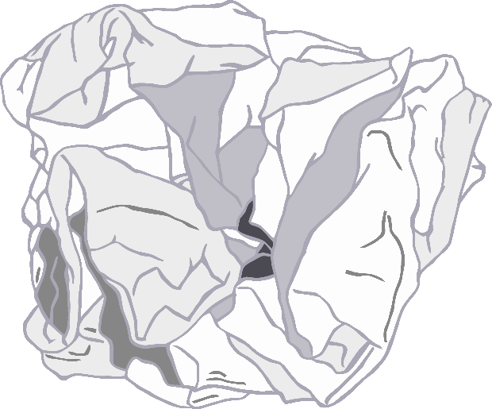



**Metal**

food tin (small)

© 2021 Little Owls Resources



**Paper** / **Card**

crumpled paper

© 2021 Little Owls Resources



**Metal**

food tin

© 2021 Little Owls Resources

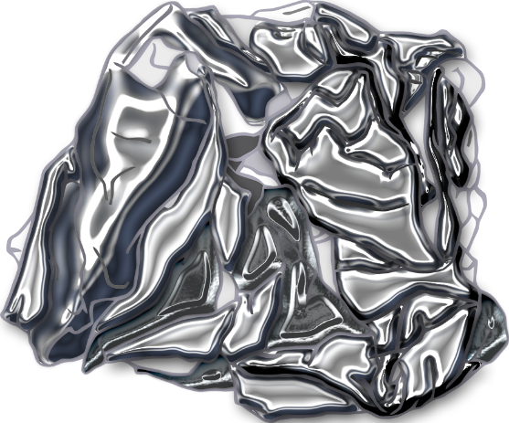



**Metal**

aluminium foil

© 2021 Little Owls Resources



**Metal**

drink can

© 2021 Little Owls Resources



**Food Waste**

carrot

© 2021 Little Owls Resources



**Food Waste**

bread

© 2021 Little Owls Resources



**Food Waste**

fish

© 2021 Little Owls Resources



**Food Waste**

apple

© 2021 Little Owls Resources



**Garden Waste**

brown leaf

© 2021 Little Owls Resources



**Garden Waste**

twig

© 2021 Little Owls Resources

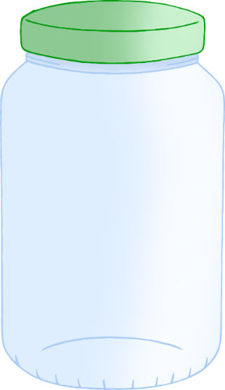



**Glass**

jar

© 2021 Little Owls Resources



**Garden Waste**

green leaf

© 2021 Little Owls Resources



**Garden Waste**

flower

© 2021 Little Owls Resources



**Glass**

green bottle

© 2021 Little Owls Resources



**Glass**

cola bottle

© 2021 Little Owls Resources



**Glass**

brown bottle

© 2021 Little Owls Resources