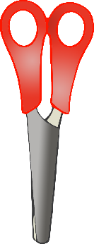

**Read a Book!**

**Read a Book!**

© 2020 Little Owls Resources

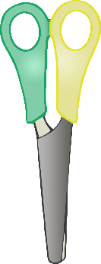

**Read a Book!**

**Read a Book!**

© 2020 Little Owls Resources

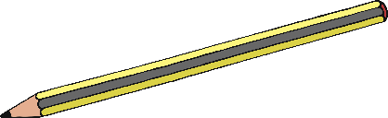



**Read a Book!**

**Read a Book!**

© 2020 Little Owls Resources



**My Favourite Book!**

**My Favourite Book!**

© 2020 Little Owls Resources

