* Fact posters x2 (Could be used as stimuli for a lesson input)
* Pompom mat (Can be used for matching colours. Moving soft pompoms also promotes fine motor skills)
* Number slice activity (1-10) (Can be pre-cut for a pure number ordering activity or left to be cut by child to add scissor practice)
* Number slice activity - colouring version (1-10) (As above but to be coloured before cutting)
* Descriptive words poster (Could be used as stimuli for a lesson input)
* Descriptive words writing sheet (Can be used as an independent writing activity or with an adult scribing the ideas of a younger child)
* A4 poster
* A4 poster - colouring version
* ‘Body Parts’ x3 (fully labelled, initial sounds only, blank)
* Follow lines sheets – large (x4) (ideally pre-laminated to be used with a whiteboard pen)
* Follow lines sheets – large (x2) (ideally pre-laminated to be used with a whiteboard pen)
* Draw and write sheets x4 (blank sheet, wide lines, narrow lines, only lines)
* 1 x 4-piece puzzle
* 2 x 2-piece puzzle
* Rabbits Multimat (for Colouring/Art & Craft/Loose Parts/Playdough)

**This pack includes:**

**Rabbit**

The pages of this pack give some general information about rabbits and some fun and engaging activities to foster and develop children’s interest in them.

© 2022 Little Owls Resources

This pack includes:

The pages of this pack give some general information about the role of a paramedic and some fun and engaging activities to foster and develop children’s interest in this role in society.

© 2022 Little Owls Resources

**Rabbit Facts**

Rabbits can live for up to

years.

**10**

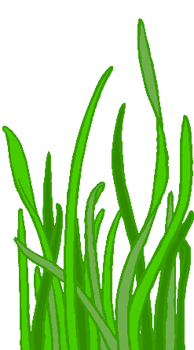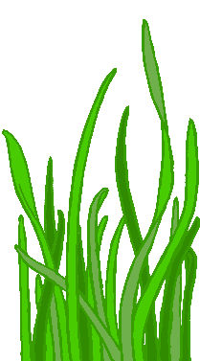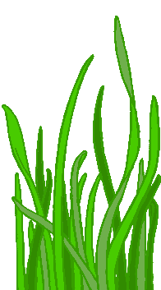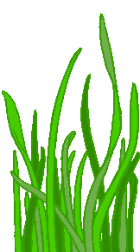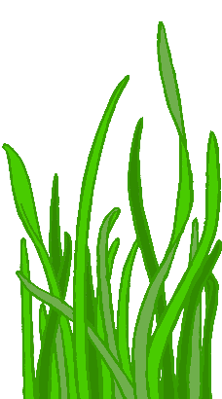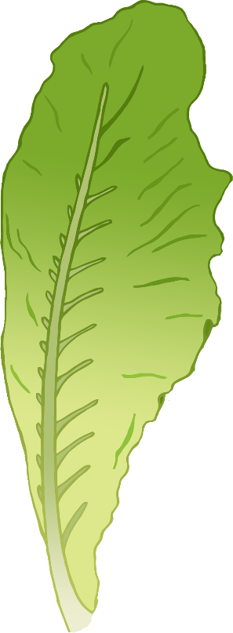

Rabbits’ teeth never stop growing! The teeth are worn down by the rough food the rabbits eat, like hay and grass. This keeps the teeth the same length.

Rabbits love to eat hay, grass, and fresh vegetables.

Rabbits can be easily frightened by loud noises and sudden movements. In fact, big shocks can be very bad for their health.

Rabbits are very social animals. They feel most safe and secure when around other rabbits.

Many people call a baby rabbit a bunny, but its proper name is a **kitten**.

**Rabbit Facts**

© 2022 Little Owls Resources

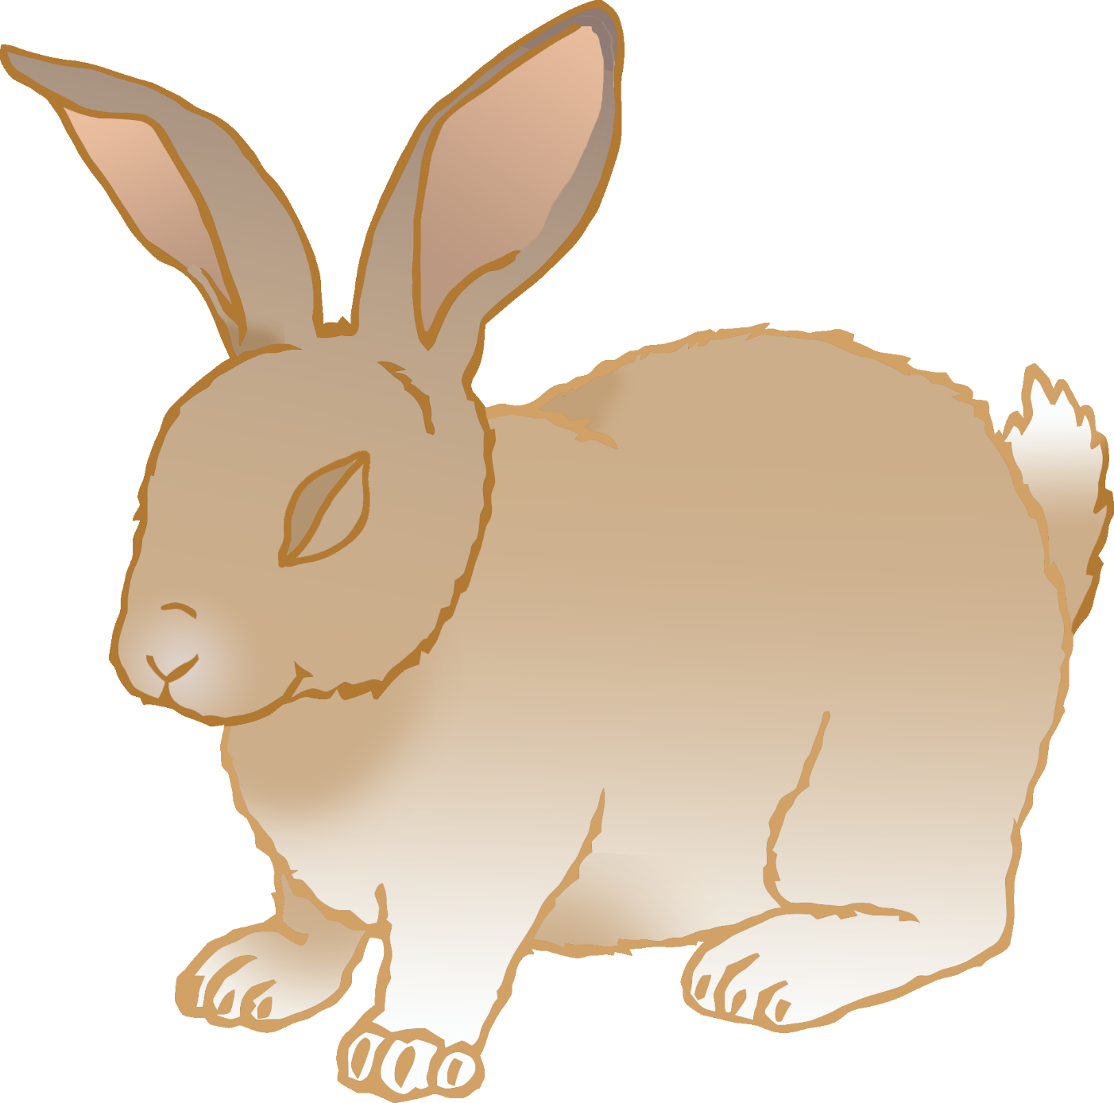

© 2022 Little Owls Resources

**How big is a rabbit?**

*(Average size)*

40 cm

© 2021 Little Owls Resources

1

2

3

4

5

6

7

8

9

10

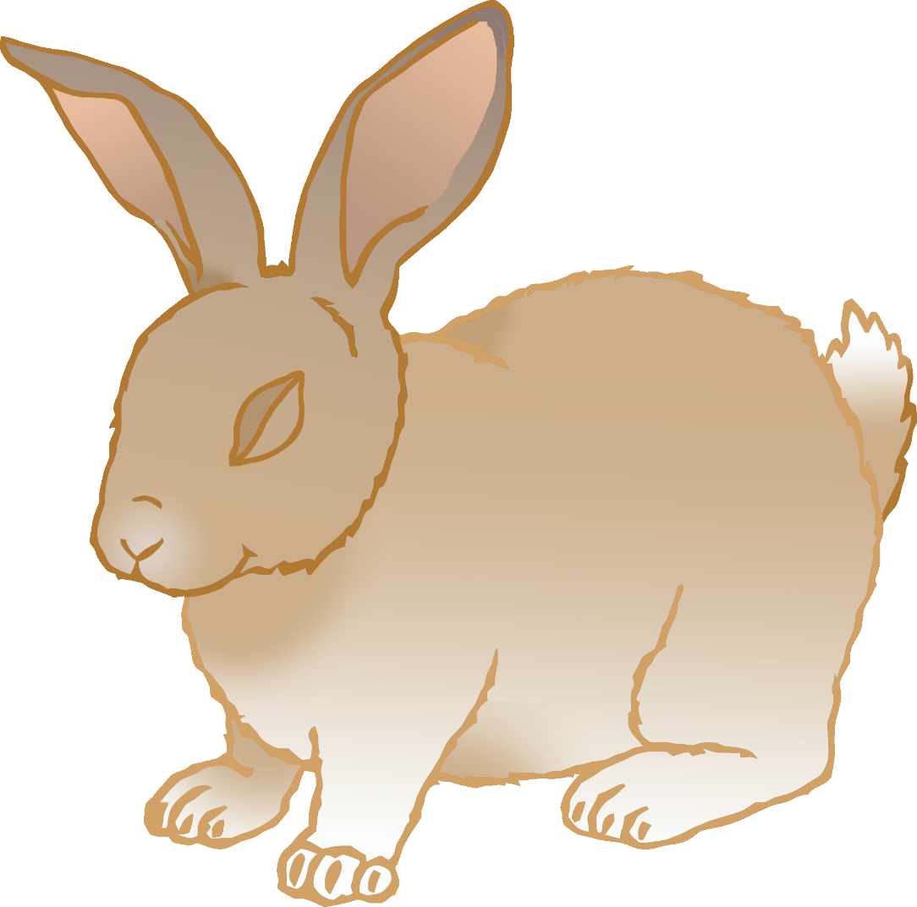

© 2022 Little Owls Resources

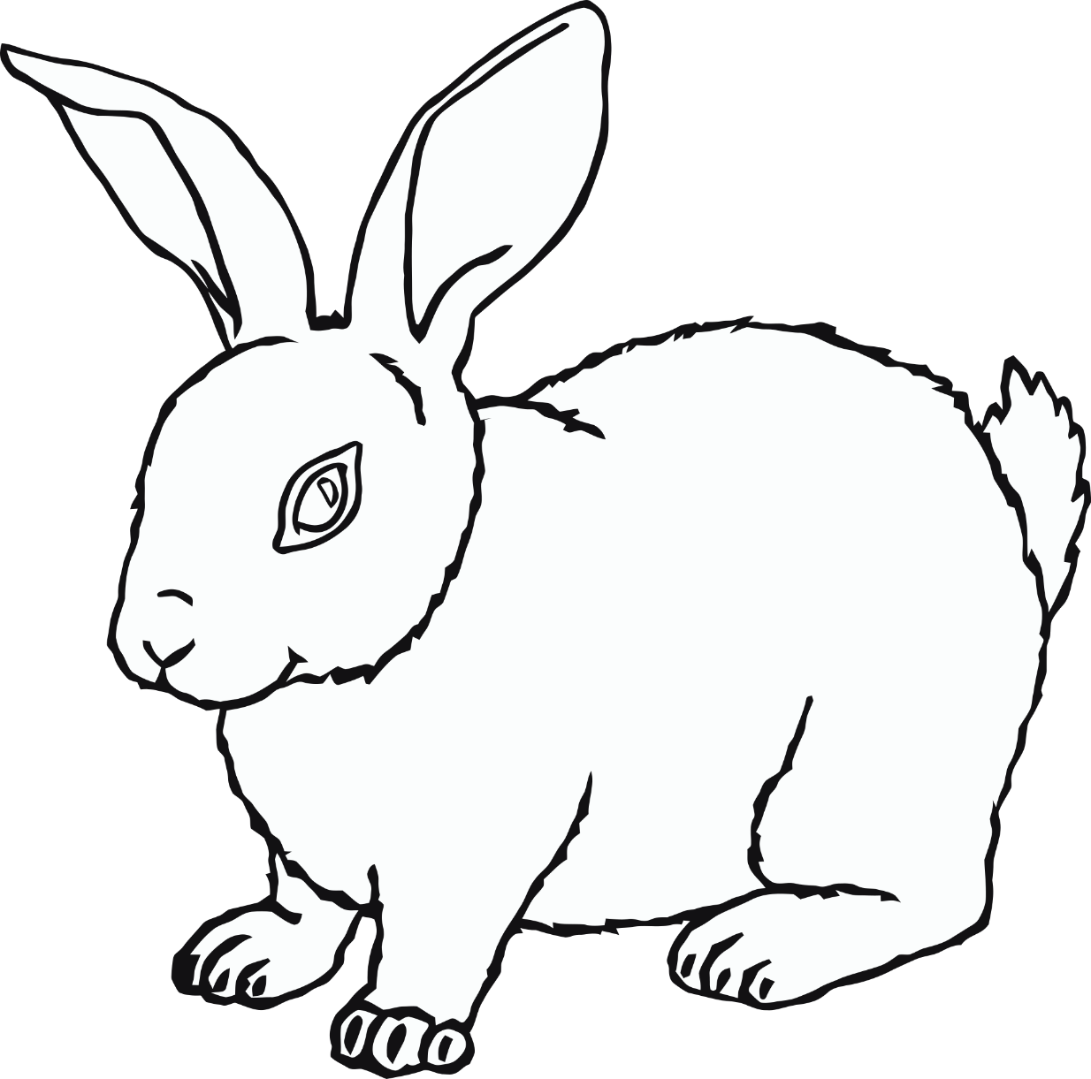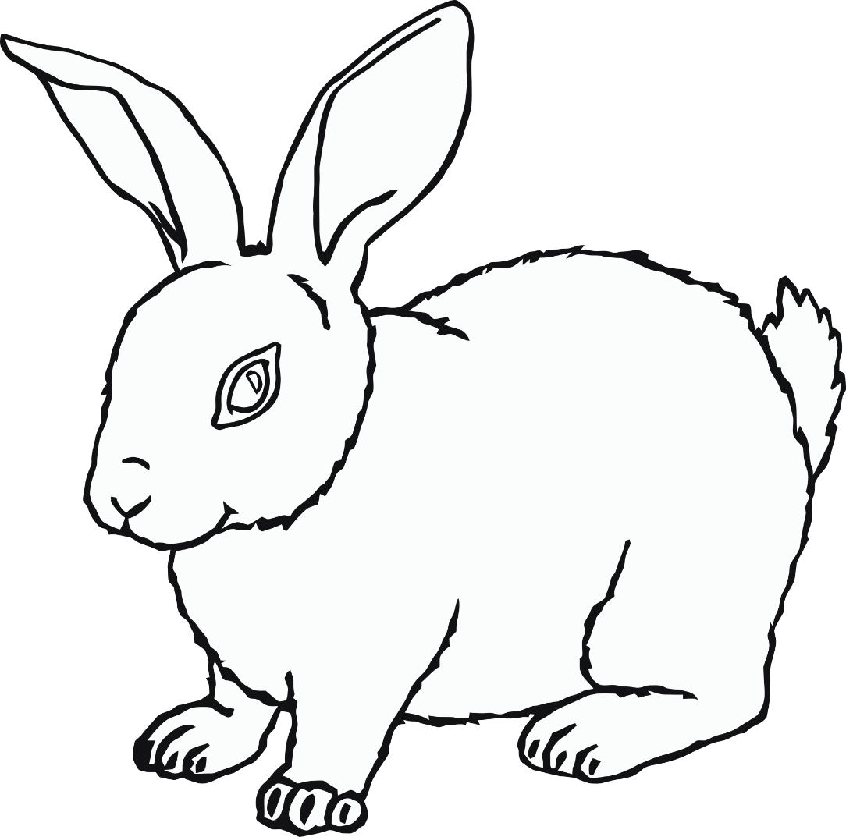

© 2022 Little Owls Resources

1

2

3

4

5

6

7

8

9

10

© 2022 Little Owls Resources

bouncy

small

soft

shy

little

frightened

furry

floppy

jump

fluffy

hop

**words**

**Rabbit**

© 2022 Little Owls Resources

**What words do you use when talking about rabbits?**

**Rabbit**

© 2022 Little Owls Resources

**Rabbit**

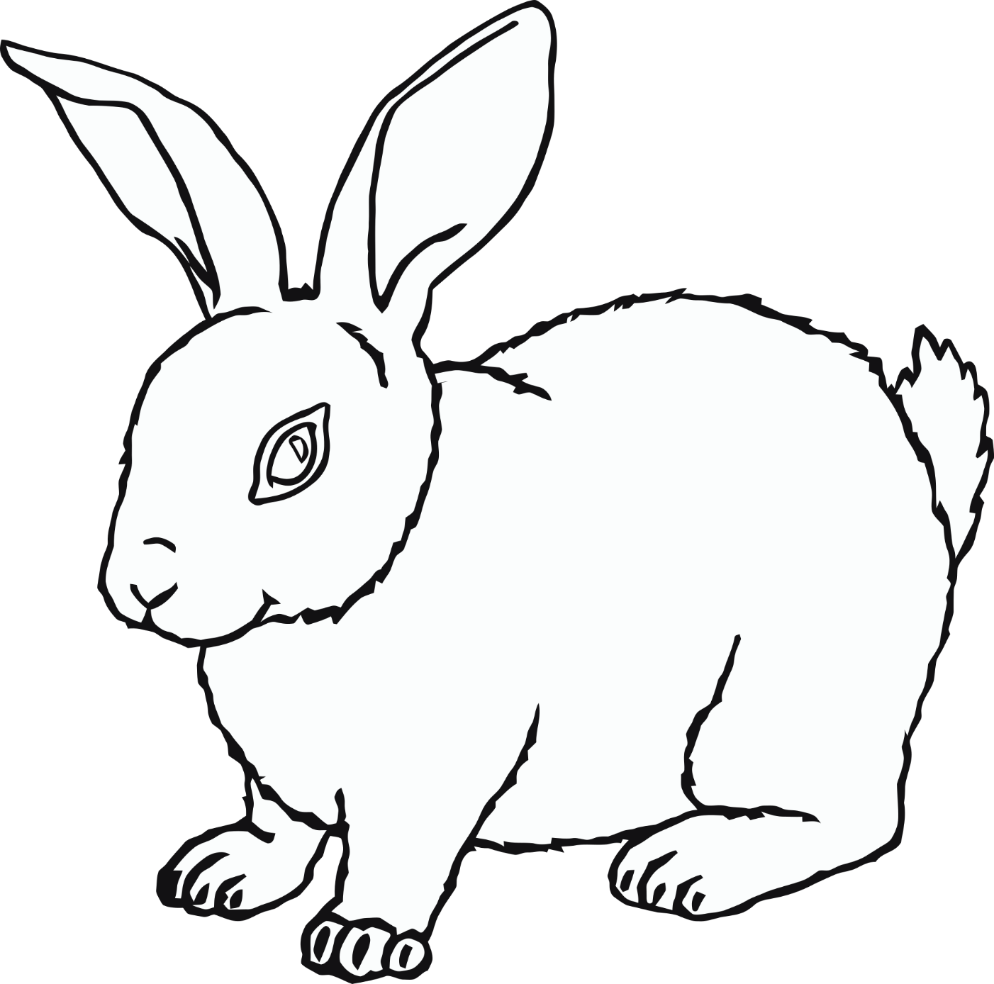

© 2022 Little Owls Resources

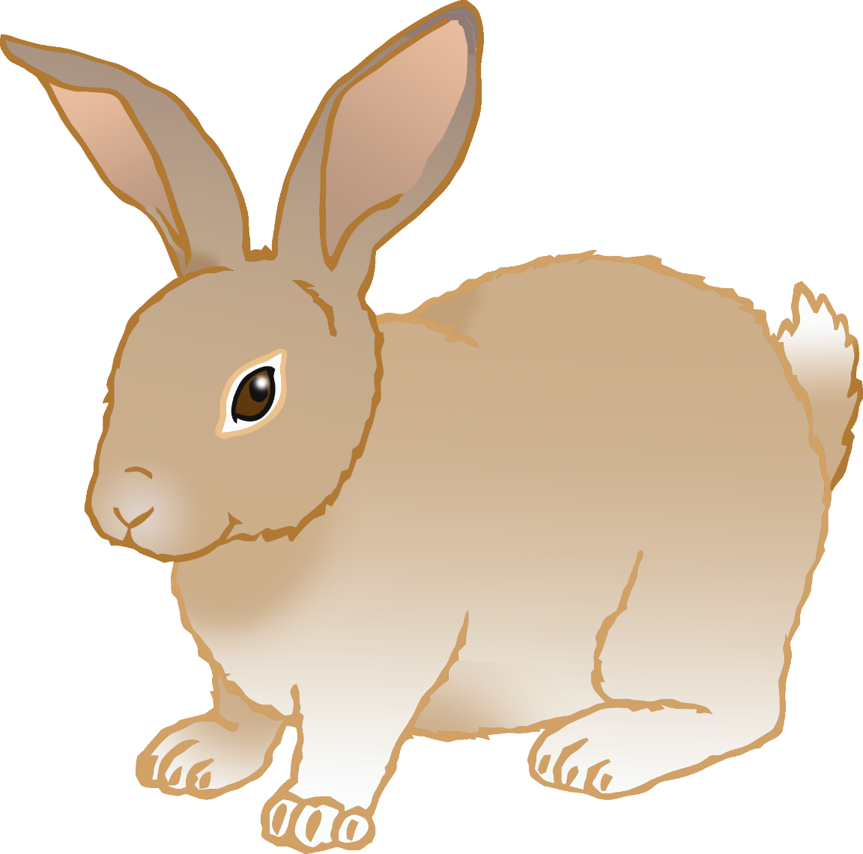

**Rabbit body parts**

© 2022 Little Owls Resources

ear

tail

nose

foot

leg



**Rabbit body parts**

© 2022 Little Owls Resources

e

t

n

f

l



**Rabbit body parts**

© 2022 Little Owls Resources

**Help the rabbit get to the food!** (1)



© 2022 Little Owls Resources

© 2022 Little Owls Resources

**Help the rabbit get to the food!** (2)

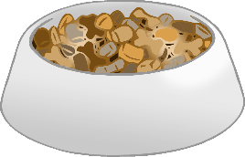



© 2022 Little Owls Resources

**Help the rabbit get to the food!** (3)



© 2022 Little Owls Resources

**Help the rabbit get to the food!** (4)

**Help the rabbit get to the food!** (1)

© 2022 Little Owls Resources

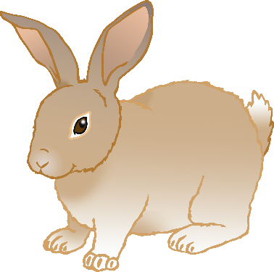

**Help the rabbit get to the food!** (2)

© 2022 Little Owls Resources



**Draw a rabbit**

© 2022 Little Owls Resources



**Draw and write about a rabbit**

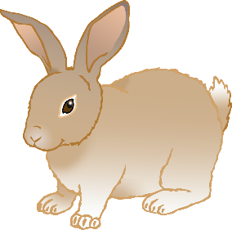

© 2022 Little Owls Resources

________­­­­­­­­­­­­­­­­­­­______________________

______________________________

______________________________

______________________________

­______________________________

______________________________

­______________________________

______________________________

**Draw and write about a rabbit**



© 2022 Little Owls Resources

**________­­­­­­­­­­­­­­­­­­­______________________**

**______________________________**

**______________________________**

**______________________________**

**­______________________________**

**______________________________**

**­______________________________**

**Write about a rabbit**



© 2022 Little Owls Resources

**______________________________________________________**

­**______________________________________________________**

**______________________________________________________**

**______________________________________________________**

**______________________________________________________**

**______________________________________________________**

**______________________________________________________**

**Rabbit**

© 2022 Little Owls Resources

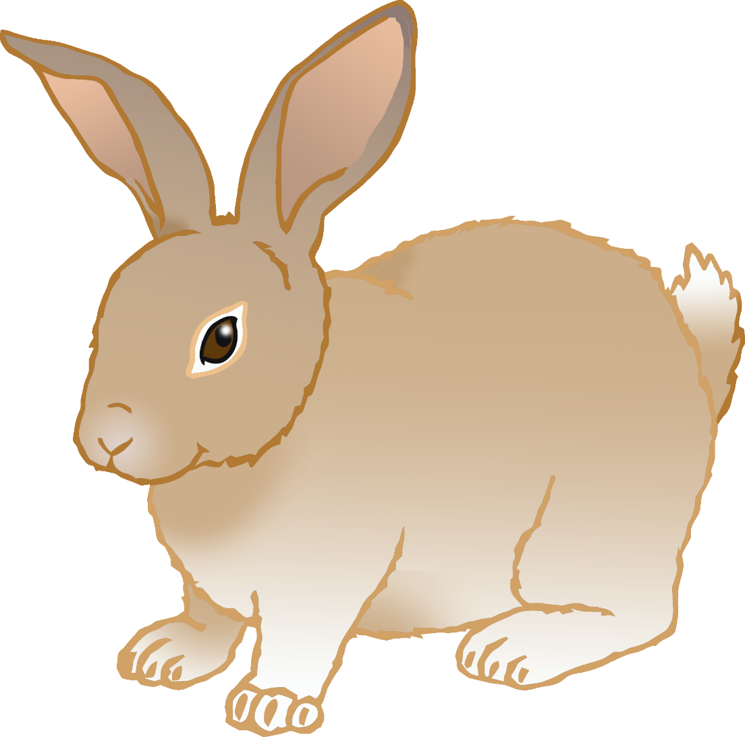

© 2022 Little Owls Resources



© 2022 Little Owls Resources

**Rabbit**

**Rabbit**

© 2022 Little Owls Resources

**Rabbit Multimat**

