I ha

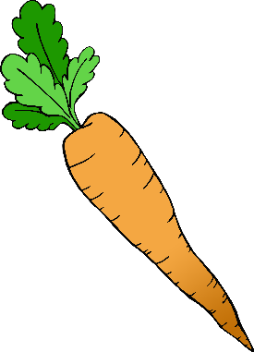

I need **1** carrot.

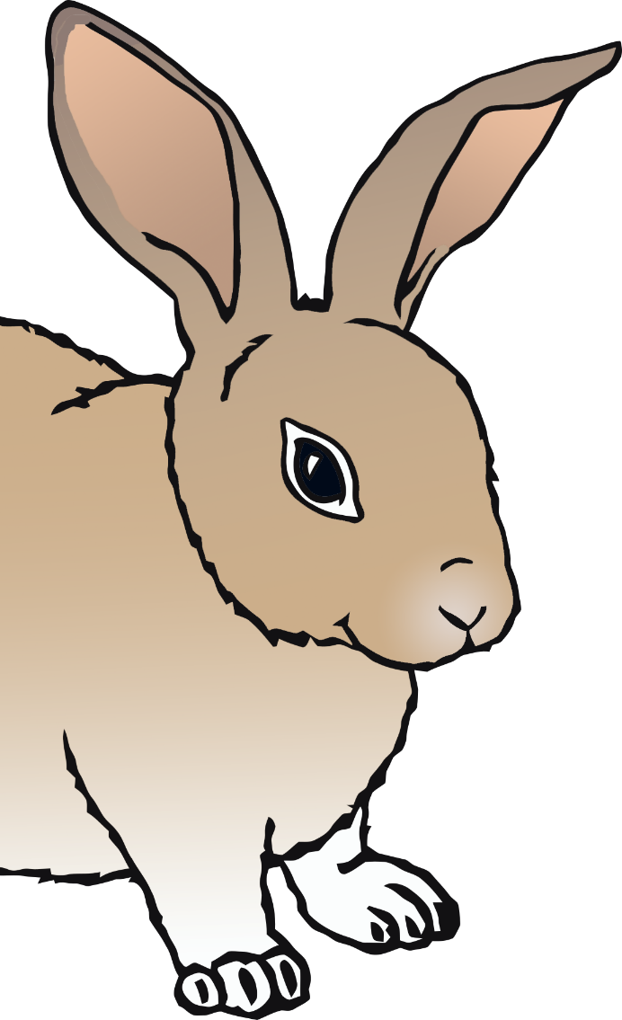

Can you make some carrots for the rabbit?

© 2020 Little Owls Resources

I ha



I need **2** carrots.



© 2020 Little Owls Resources

Can you make some carrots for the rabbit?

I ha



I need **3** carrots.



Can you make some carrots for the rabbit?

© 2020 Little Owls Resources

© 2020 Little Owls Resources

I ha



I need **4** carrots.



© 2020 Little Owls Resources

Can you make some carrots for the rabbit?

I ha



I need **5** carrots.



Can you make some carrots for the rabbit?

© 2020 Little Owls Resources

I ha



I need **6** carrots.



Can you make some carrots for the rabbit?

© 2020 Little Owls Resources

I ha



I need **7** carrots.



Can you make some carrots for the rabbit?

© 2020 Little Owls Resources

I ha



I need **8** carrots.



Can you make some carrots for the rabbit?

© 2020 Little Owls Resources

I ha



I need **9** carrots.



Can you make some carrots for the rabbit?

© 2020 Little Owls Resources

I ha



I need **10** carrots.



© 2020 Little Owls Resources

Can you make some carrots for the rabbit?