**Pussycat Pussycat**

© 2021 Little Owls Resources

**Pussycat, pussycatWhere have you been?I've been up to LondonTo visit the Queen.Pussycat, pussycatWhat did you there?I frightened a little mouseUnder her chair.**

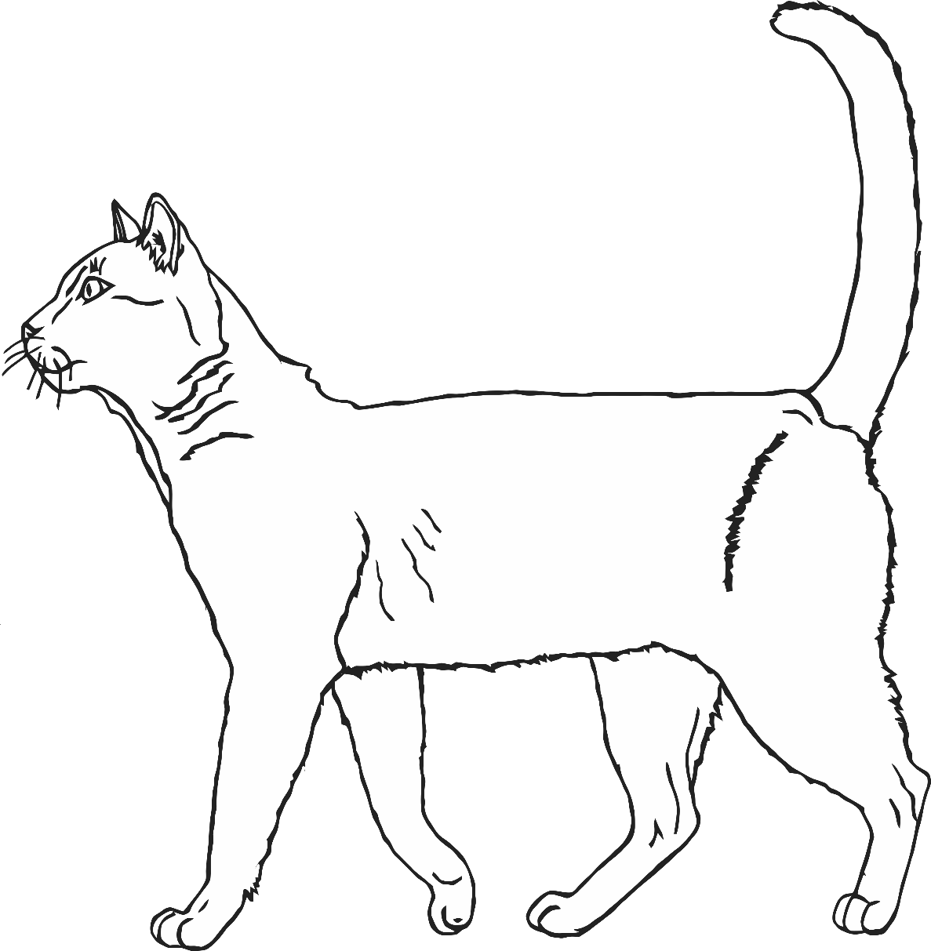

**Pussycat Pussycat**

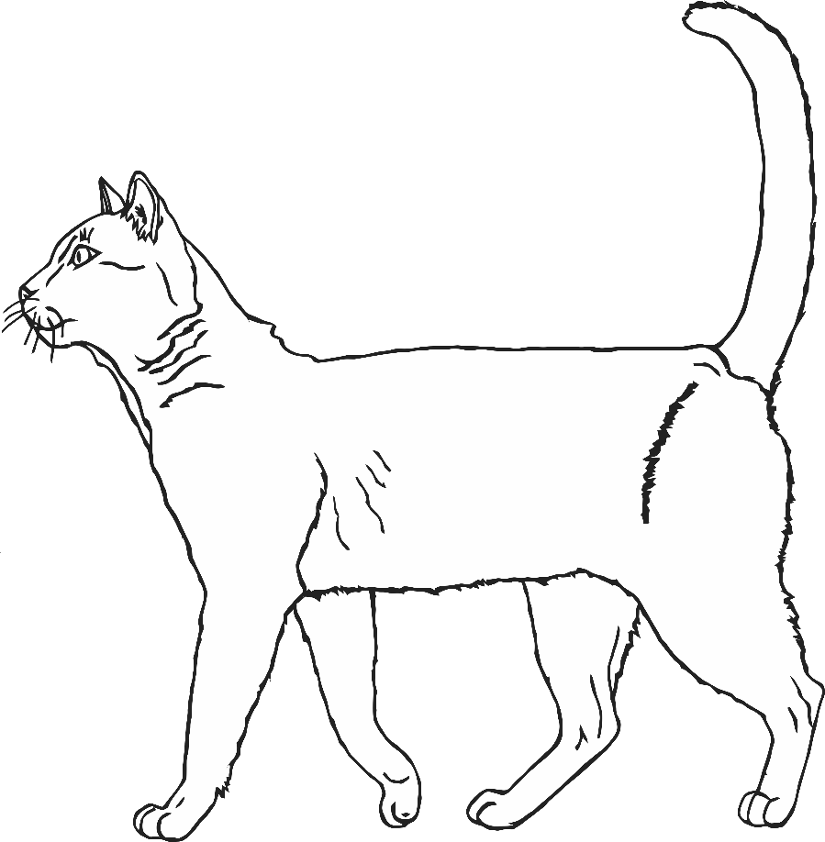

**Pussycat, pussycatWhere have you been?I've been up to LondonTo visit the Queen.Pussycat, pussycatWhat did you there?I frightened a little mouseUnder her chair.**

© 2021 Little Owls Resources