People Who Help Us

Postal Worker

© 2021 Little Owls Resources

* Information Posters
* Information Posters (Colouring)
* Drawing/Writing Sheets
* Draw items Sheet
* Draw items Sheet (Colouring)
* Item Poster
* Item Poster (Colouring)
* Multimats for Art & Craft/Loose Parts/Playdough
* 6x 2-Piece individual items puzzles
* 1x 4-Piece all items puzzle

This pack includes:

The pages of this pack give some general information about the role of a postal worker and some fun and engaging activities to foster and develop children’s interest in this role in society.

© 2023 Little Owls Resources

Postal Worker

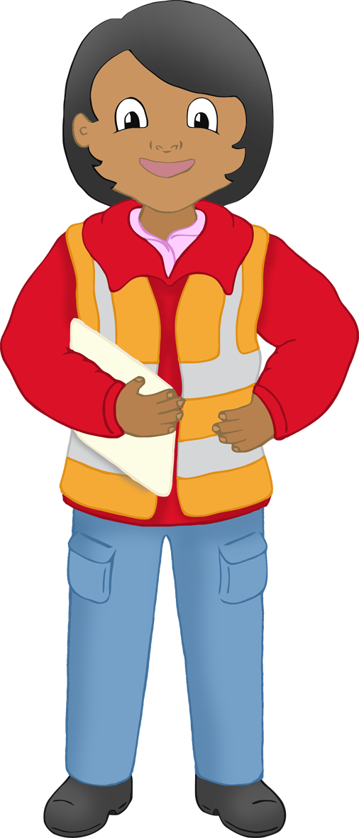

I’m a **postal worker.**

I collect letters and parcels that people want to send to someone else.

I help to sort the letters and parcels, so they get transported to the right person.

I post letters through the person’s letterbox.

I collect a large number of letters and cards that people have sent.

Postal Worker

A red and blue rectangular object with a grey rectangular object with a grey rectangular object with a grey rectangular object with a grey rectangular object with a grey rectangular object with a grey rectangular object with a grey

Sometimes I use scales to weigh the letters and parcels.

People post letters in a post box. I collect letters from the post box.

When collecting or delivering I might use a post van to help me.

© 2023 Little Owls Resources

© 2023 Little Owls Resources

Postal Worker

I collect a large number of letters and cards that people have sent.

I’m a **postal worker.**

I collect letters and parcels that people want to send to someone else.

I help to sort the letters and parcels, so they get transported to the right person.

I post letters through the person’s letterbox.

Postal Worker

Sometimes I use scales to weigh the letters and parcels.

When collecting or delivering I might use a post van to help me.

People post letters in a post box. I collect letters from the post box.

© 2023 Little Owls Resources

© 2023 Little Owls Resources

Draw a Postal Worker!

© 2023 Little Owls Resources

Postal Worker!

Draw and write about a

_________________________________________________________

© 2023 Little Owls Resources

Draw and write about a

Postal Worker!

________________________________________________________________________________________________________________________________________________

**Can you draw the items a postal worker needs?**

© 2023 Little Owls Resources

**Can you draw the items a postal worker needs?**

© 2023 Little Owls Resources

A red and blue rectangular object with a grey rectangular object with a grey rectangular object with a grey rectangular object with a grey rectangular object with a grey rectangular object with a grey rectangular object with a grey

Postal Worker

van

post box

scales

© 2023 Little Owls Resources

letters

**Postal Worker**

**van**

**post box**

**scales**

**letters**

© 2023 Little Owls Resources

Postal Worker Multimat - van

© 2023 Little Owls Resources

Postal Worker Multimat - scales

© 2023 Little Owls Resources

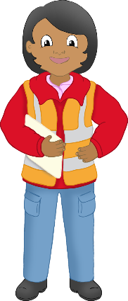

Postal Worker Multimat – post box

© 2023 Little Owls Resources

Postal Worker Multimat - letters

© 2023 Little Owls Resources

© 2023 Little Owls Resources

© 2023 Little Owls Resources

© 2023 Little Owls Resources

© 2023 Little Owls Resources

A red and blue rectangular object with a grey rectangular object with a grey rectangular object with a grey rectangular object with a grey rectangular object with a grey rectangular object with a grey rectangular object with a grey

© 2023 Little Owls Resources

© 2023 Little Owls Resources

Postal Worker

© 2023 Little Owls Resources

A red and blue rectangular object with a grey rectangular object with a grey rectangular object with a grey rectangular object with a grey rectangular object with a grey rectangular object with a grey rectangular object with a grey

letters

scales

van

post box