Poppy Poppy what do you say?

Wear me on Remembrance Day.

Poppy Poppy what do you tell?

Many soldiers in battle fell.

Poppy Poppy what should we know?

That peace on earth should

grow, grow, grow.

Author Unknown

© 2022 Little Owls Resources

Poppy Poppy

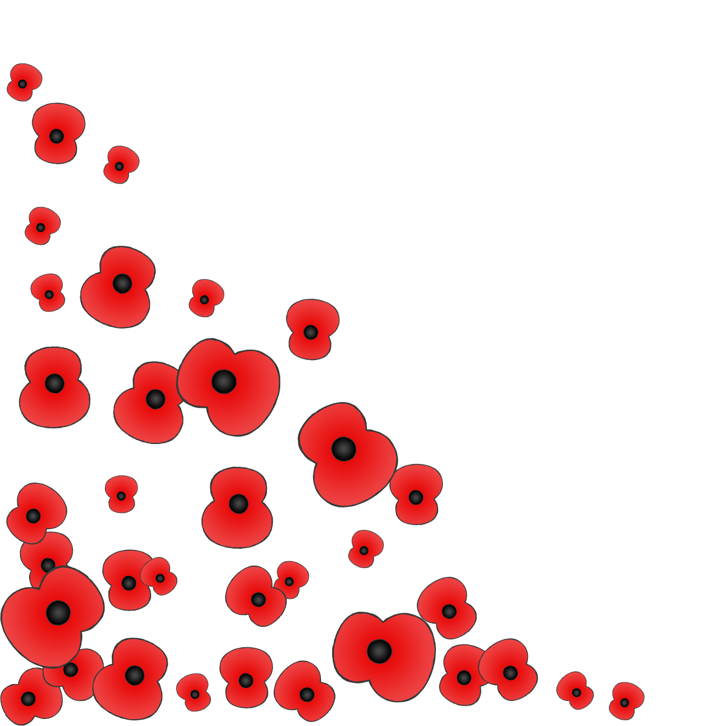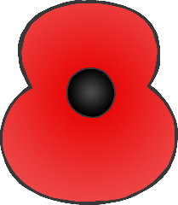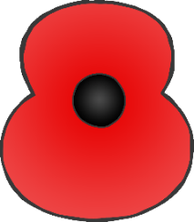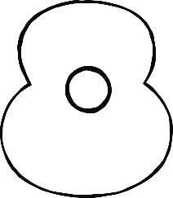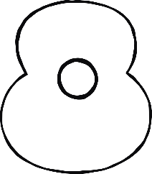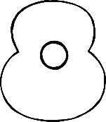

Poppy Poppy

© 2022 Little Owls Resources

Poppy Poppy what do you say?

Wear me on Remembrance Day.

Poppy Poppy what do you tell?

Many soldiers in battle fell.

Poppy Poppy what should we know?

That peace on earth should

grow, grow, grow.

Author Unknown

Poppy Poppy what do you say?

Wear me on Remembrance Day.

Poppy Poppy what do you tell?

Many soldiers in battle fell.

Poppy Poppy what should we know?

That peace on earth should

grow, grow, grow.

Author Unknown

Poppy Poppy



© 2022 Little Owls Resources

Poppy Poppy what do you say?

Wear me on Remembrance Day.

Poppy Poppy what do you tell?

Many soldiers in battle fell.

Poppy Poppy what should we know?

That peace on earth should

grow, grow, grow.

Author Unknown

Poppy Poppy

© 2022 Little Owls Resources

