People Who Help Us

Police Officer

* Information Posters
* Information Posters (Colouring)
* Drawing/Writing Sheets
* Draw items Sheet
* Draw items Sheet (Colouring)
* Item Poster
* Item Poster (Colouring)
* Multimats for Art & Craft/Loose Parts/Playdough
* 5x 2-Piece individual items puzzles
* 1x 4-Piece all items puzzle

This pack includes:

The pages of this pack give some general information about the role of a police officer and some fun and engaging activities to foster and develop children’s interest in this role in society.

© 2021 Little Owls Resources

© 2021 Little Owls Resources

Police Officer

I’m a **police officer.**

It is my job to keep everyone safe and to stop people committing crimes.

If I think a person has committed a crime, it is my job to find out all about it and then arrest them if I need to.

I use a police car to travel quickly to and from emergencies.

Police Officer

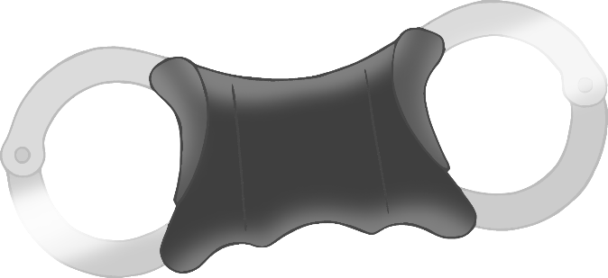

I have a notepad to write down any important information.

I have a walkie talkie so I can talk with other police officers.

If I arrest someone, I may put handcuffs on them.

© 2021 Little Owls Resources

© 2021 Little Owls Resources

**Police Officer**

**I’m a police officer.**

**It is my job to keep everyone safe and to stop people committing crimes.**

**If I think a person has committed a crime, it is my job to find out all about it and then arrest them if I need to.**

**I use a police car to travel quickly to and from emergencies.**

**Police Officer**

**I have a notepad to write down any important information.**

**I have a walkie talkie so I can talk with other police officers.**

**If I arrest someone, I may put handcuffs on them.**

© 2021 Little Owls Resources

© 2021 Little Owls Resources

Draw a Police Officer!

© 2021 Little Owls Resources

Draw and write about a Police Officer!

_________________________________________________________

© 2021 Little Owls Resources

Draw and write about a Police Officer!

________________________________________________________________________________________________________________________________________________

**Can you draw the items a police officer needs?**

© 2021 Little Owls Resources

**Can you draw the items a police officer needs?**

© 2021 Little Owls Resources

Police Officer

© 2021 Little Owls Resources

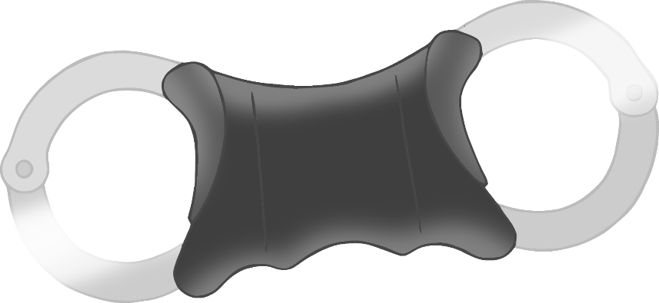

Handcuffs

Police Car

Notepad

Walkie Talkie

**Police Officer**

© 2021 Little Owls Resources

**Notepad**

**Police Car**

**Walkie Talkie**

**Handcuffs**

Police Officer Multimat – Police Car

© 2021 Little Owls Resources

Police Officer Multimat - Notepad

© 2021 Little Owls Resources

Police Officer Multimat – Handcuffs

© 2021 Little Owls Resources

Police Officer Multimat – Walkie Talkie

© 2021 Little Owls Resources

© 2021 Little Owls Resources

© 2021 Little Owls Resources

© 2021 Little Owls Resources

© 2021 Little Owls Resources

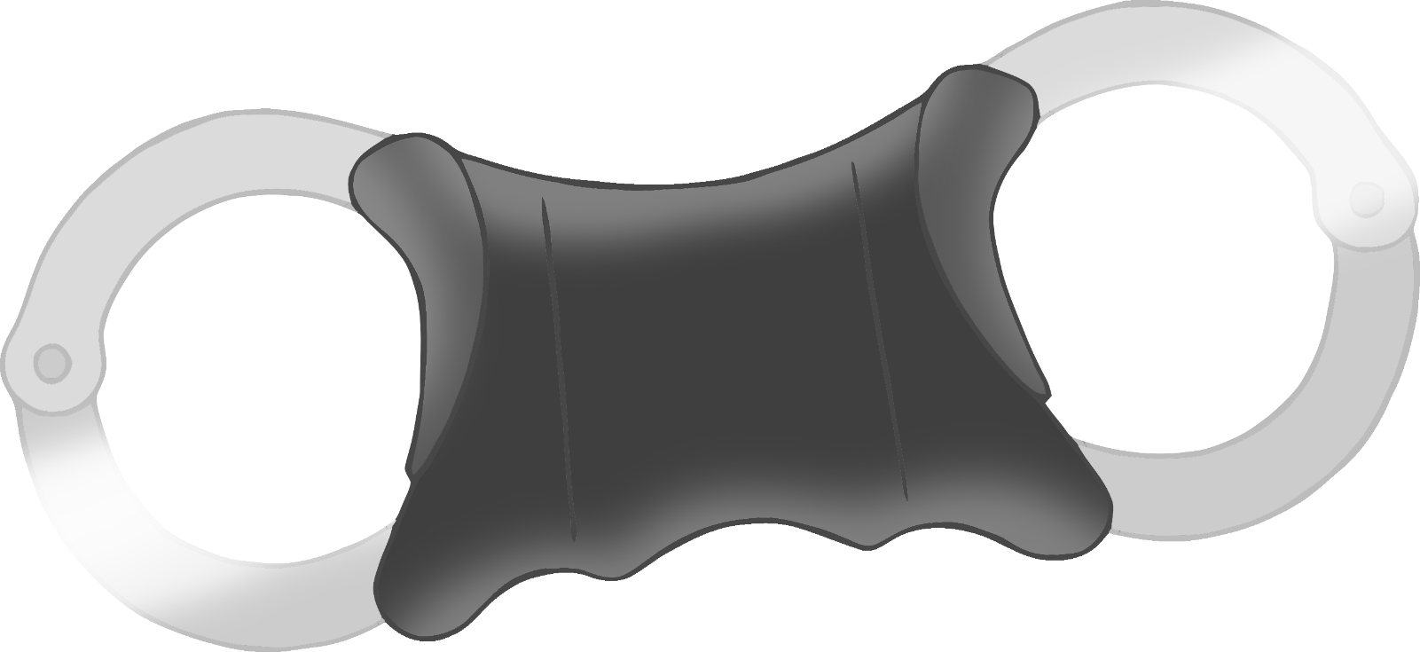

© 2021 Little Owls Resources

**Police Officer**

© 2021 Little Owls Resources

Police Car

Notepad

Handcuffs

Walkie Talkie