**Polar Bear body parts**

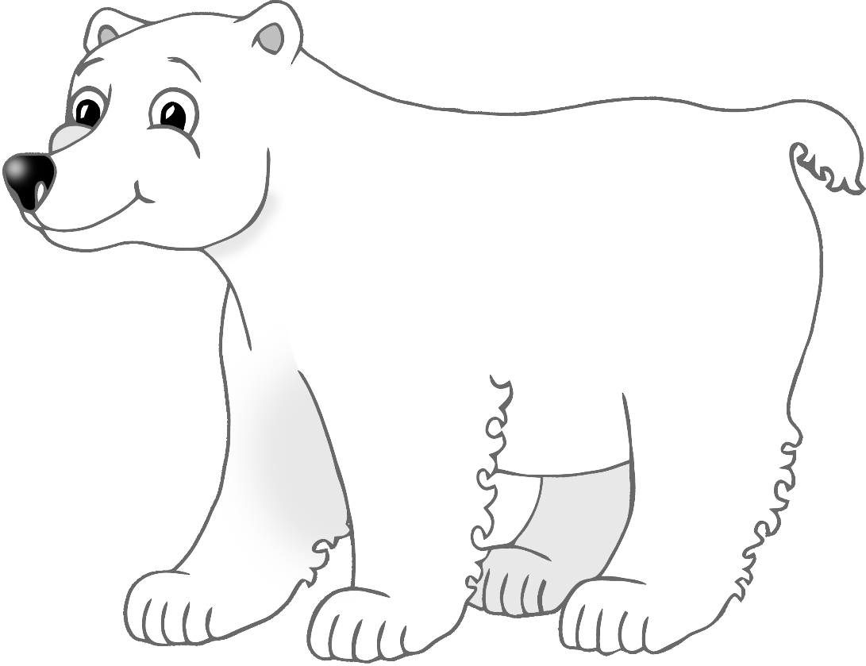

© 2021 Little Owls Resources



e

f

t

p

n

**Polar Bear body parts**

© 2021 Little Owls Resources



ear

fur

tail

paw

nose

**Polar Bear body parts**

© 2021 Little Owls Resources