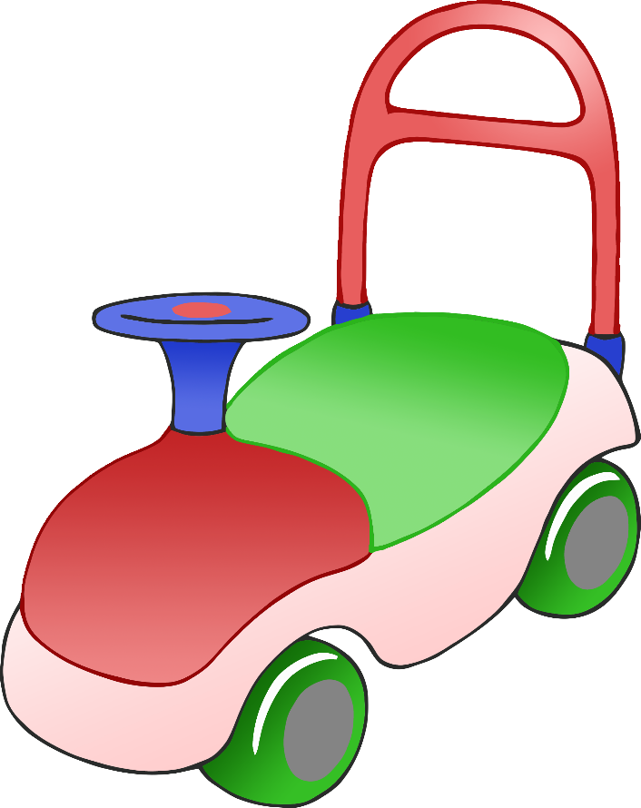

**After playtime…**

**Wash your hands!**