**Make some playdough teeth!**

© 2021 Little Owls Resources

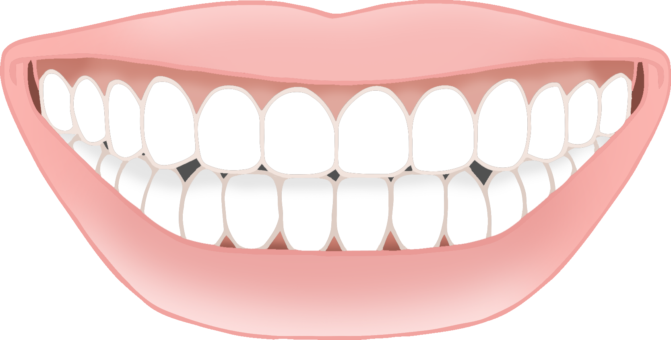

**Make some playdough teeth!**

© 2021 Little Owls Resources