**Q**ueen

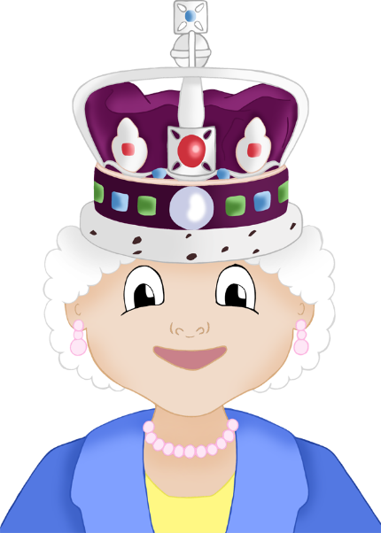

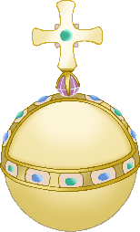

coronation

corgi

© 2022 Little Owls Resources

© 2022 Little Owls Resources

© 2022 Little Owls Resources

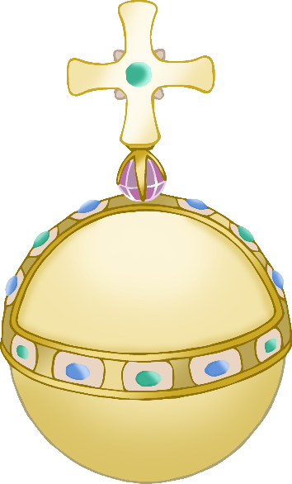

orb

crown

throne

© 2022 Little Owls Resources

© 2022 Little Owls Resources

© 2022 Little Owls Resources

© 2022 Little Owls Resources

© 2022 Little Owls Resources

© 2022 Little Owls Resources

sceptre

British flag

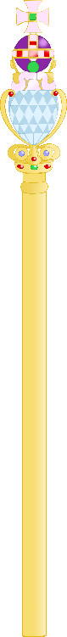

Platinum Jubilee emblem

Jubilee party

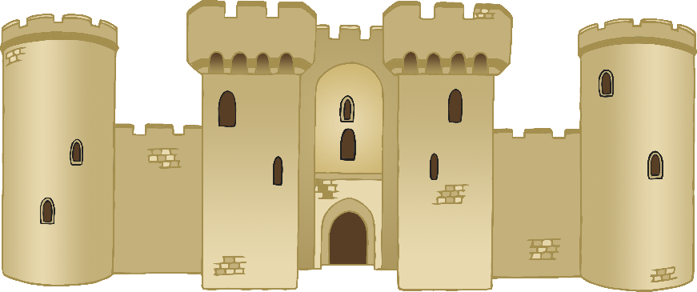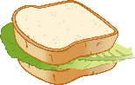

castle



© 2022 Little Owls Resources

© 2022 Little Owls Resources