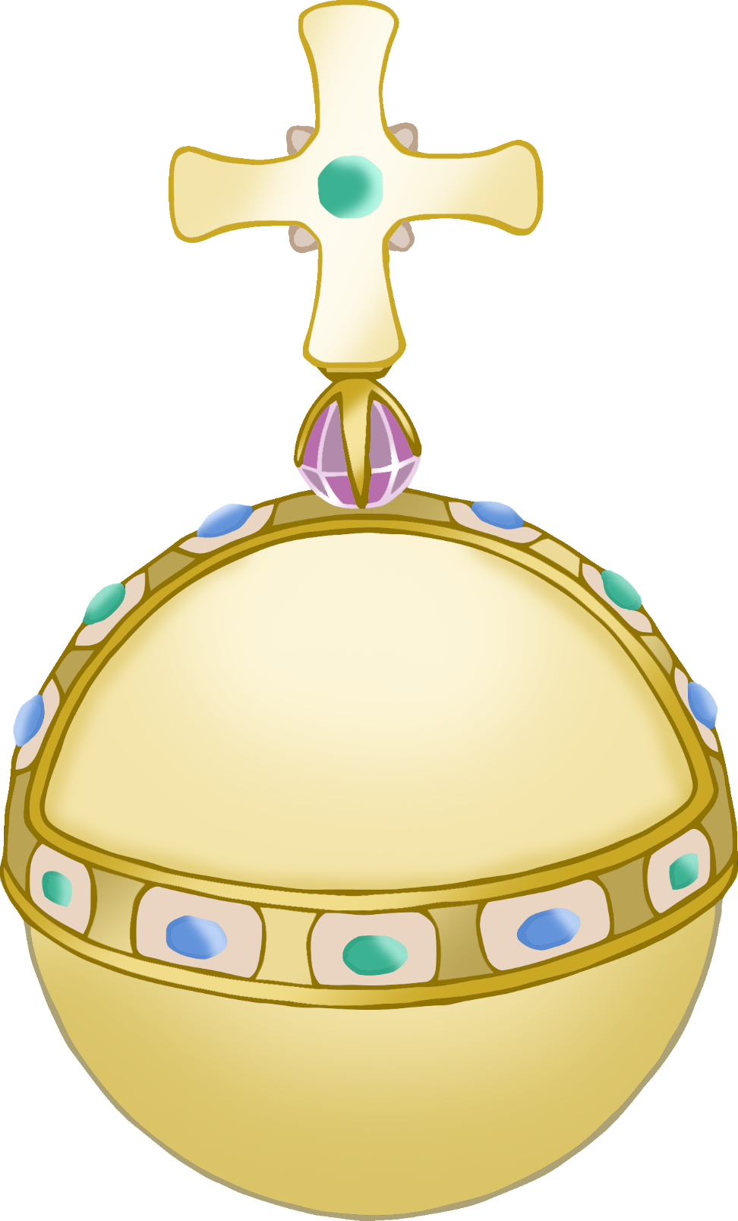

© 2022 Little Owls Resources

or

b

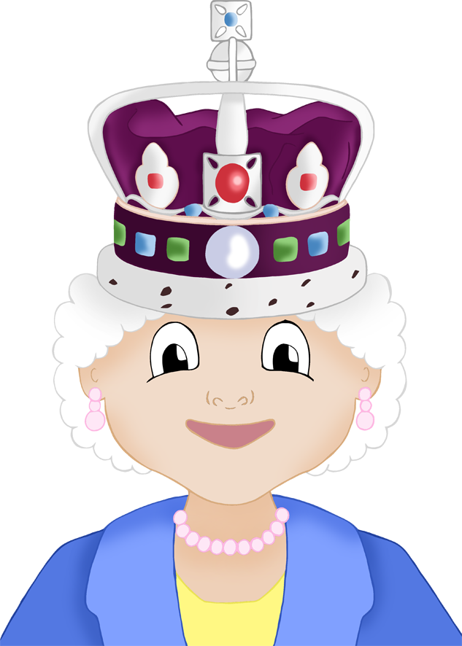

qu

ee

n

© 2022 Little Owls Resources

f

oo

d

© 2022 Little Owls Resources

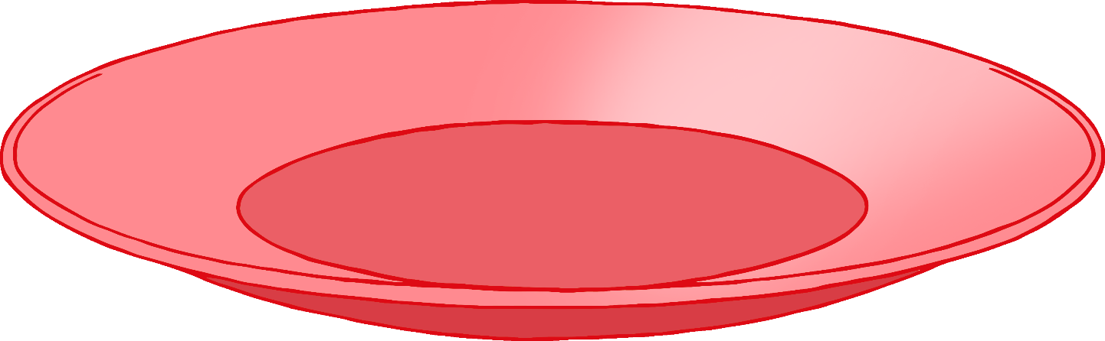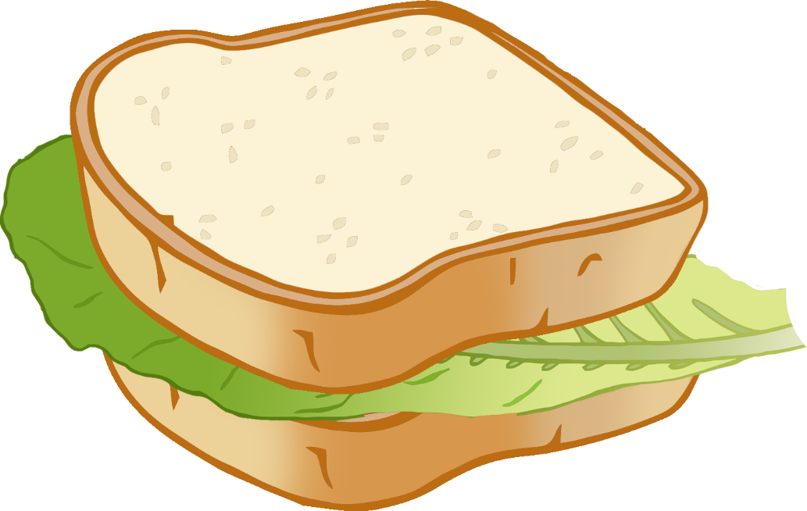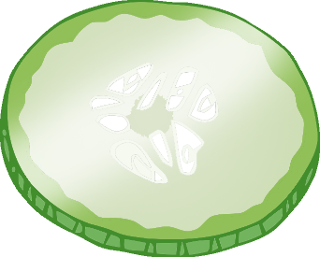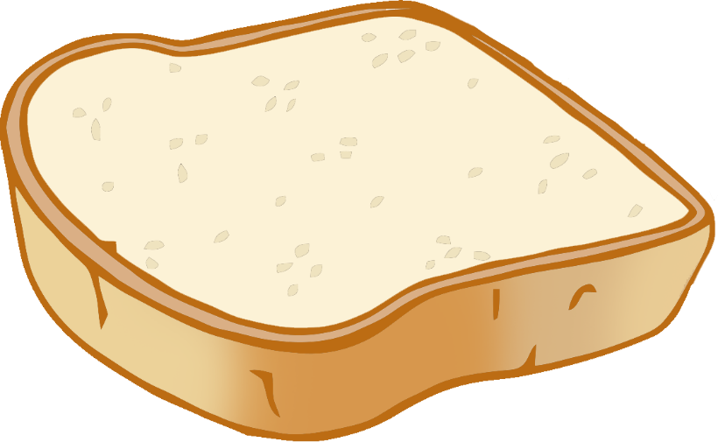

f

l

a

g

© 2022 Little Owls Resources

c

r

o**w**

n

© 2022 Little Owls Resources

p

ar

t

y

© 2022 Little Owls Resources