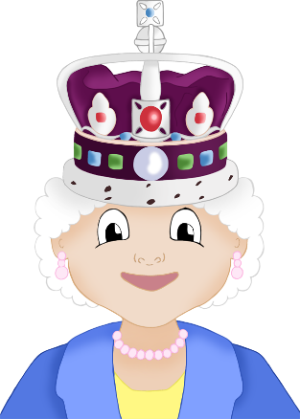

**Platinum Jubilee Word Mat**

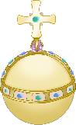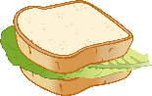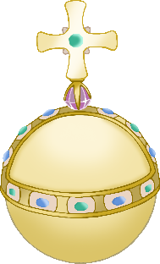

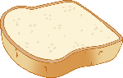

British flag

Jubilee party

Platinum Jubilee emblem

orb

sceptre

crown

**Q**ueen

corgi

coronation

throne

© 2022 Little Owls Resources