© 2022 Little Owls Resources

© 2022 Little Owls Resources

© 2022 Little Owls Resources

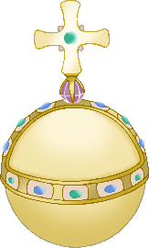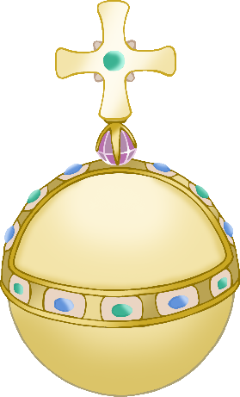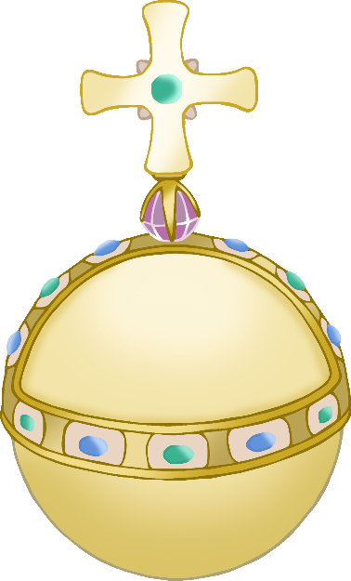

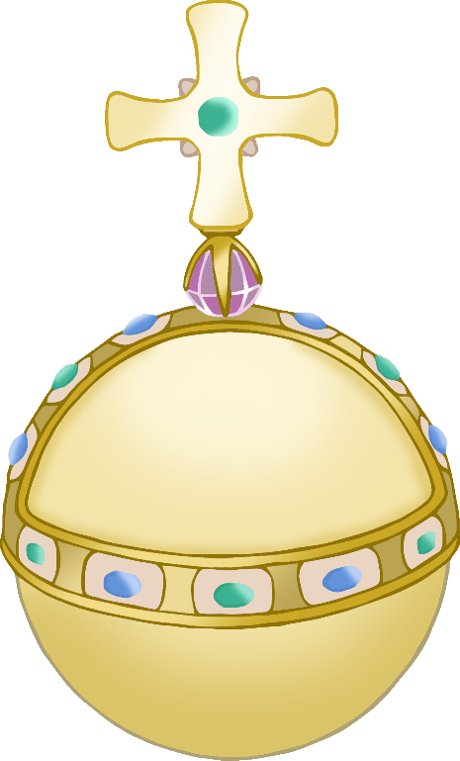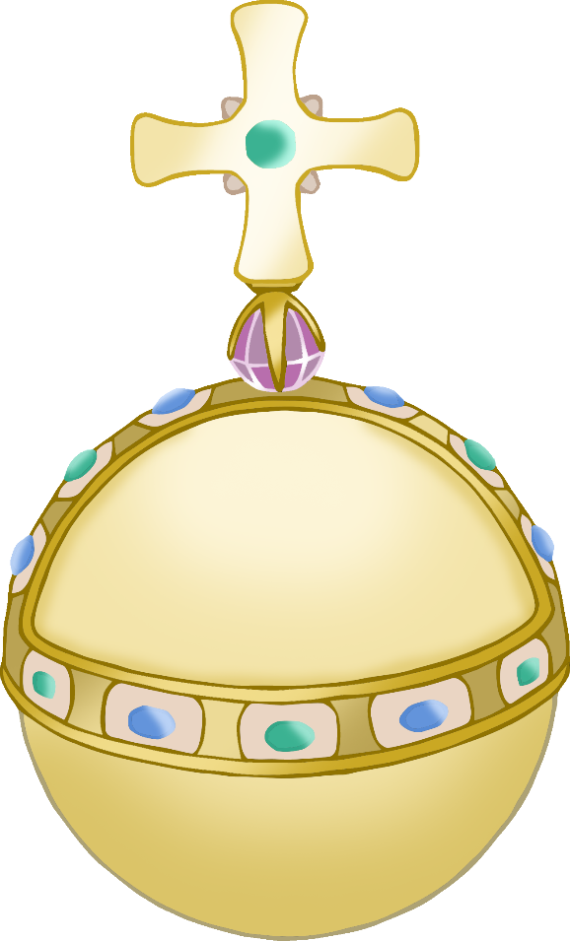

© 2022 Little Owls Resources

© 2022 Little Owls Resources

© 2022 Little Owls Resources