Platinum Jubilee

© 2022 Little Owls Resources

c

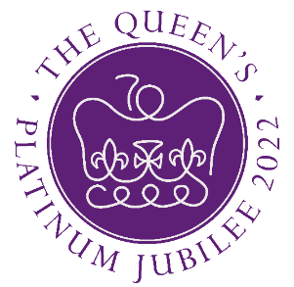

**1952 - 2022**

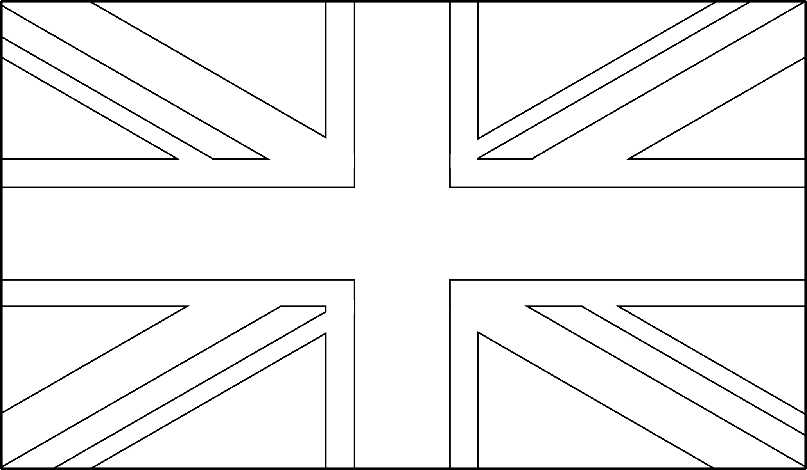

Platinum Jubilee



© 2022 Little Owls Resources

c

**1952 - 2022**