**Plants Word Mat**

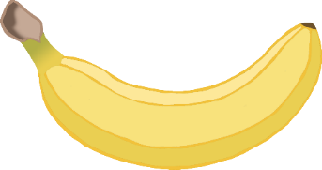

vegetables

sunlight

grow

water

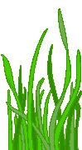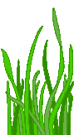

soil

seeds

nuts

fruit

trees

flowers

leaves

grass

© 2022 Little Owls Resources