flowers

trees

© 2022 Little Owls Resources

© 2022 Little Owls Resources

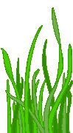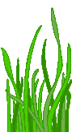

leaves

grass

© 2022 Little Owls Resources

© 2022 Little Owls Resources

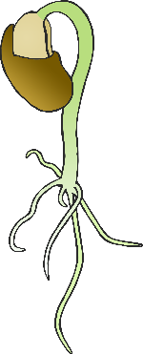

grow

water

© 2022 Little Owls Resources

© 2022 Little Owls Resources

vegetables

sunlight

© 2022 Little Owls Resources

© 2022 Little Owls Resources

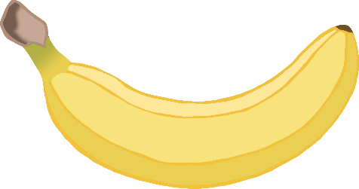

© 2022 Little Owls Resources

nuts

fruit

© 2022 Little Owls Resources

soil

seeds

© 2022 Little Owls Resources

© 2022 Little Owls Resources