© 2021 Little Owls Resources



Can you make some **leaves** using playdough?

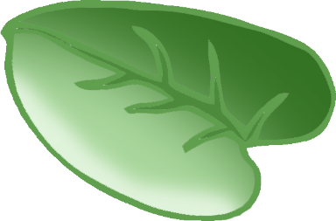

Make **1** leaf.

© 2021 Little Owls Resources



Can you make some **leaves** using playdough?



Make **2** leaves.

© 2021 Little Owls Resources



Can you make some **leaves** using playdough?



Make **3** leaves.

© 2021 Little Owls Resources



Can you make some **leaves** using playdough?



Make **4** leaves.

© 2021 Little Owls Resources



Can you make some **leaves** using playdough?



Make **5** leaves.

© 2021 Little Owls Resources



Can you make some **leaves** using playdough?



Make **6** leaves.

© 2021 Little Owls Resources



Can you make some **leaves** using playdough?



Make **7** leaves.

© 2021 Little Owls Resources



Can you make some **leaves** using playdough?



Make **8** leaves.

© 2021 Little Owls Resources



Can you make some **leaves** using playdough?



Make **9** leaves.

© 2021 Little Owls Resources



Can you make some **leaves** using playdough?



Make **10** leaves.