**Plants make…**

© 2022 Little Owls Resources

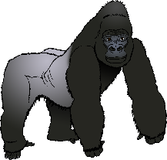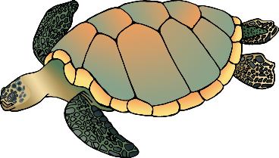

Animals (including humans) need this **oxygen** in the air and water to breathe!

oxygen