**What does a houseplant need?**

© 2020 Little Owls Resources

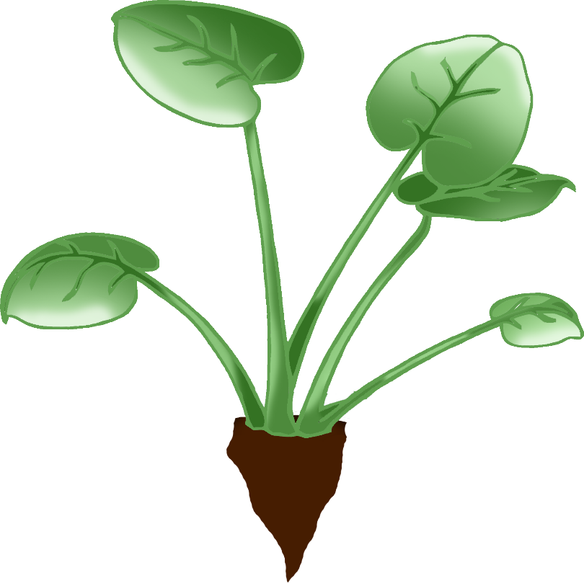

Sunlight

Water

Pot of soil