**What does a houseplant need?**

© 2022 Little Owls Resources

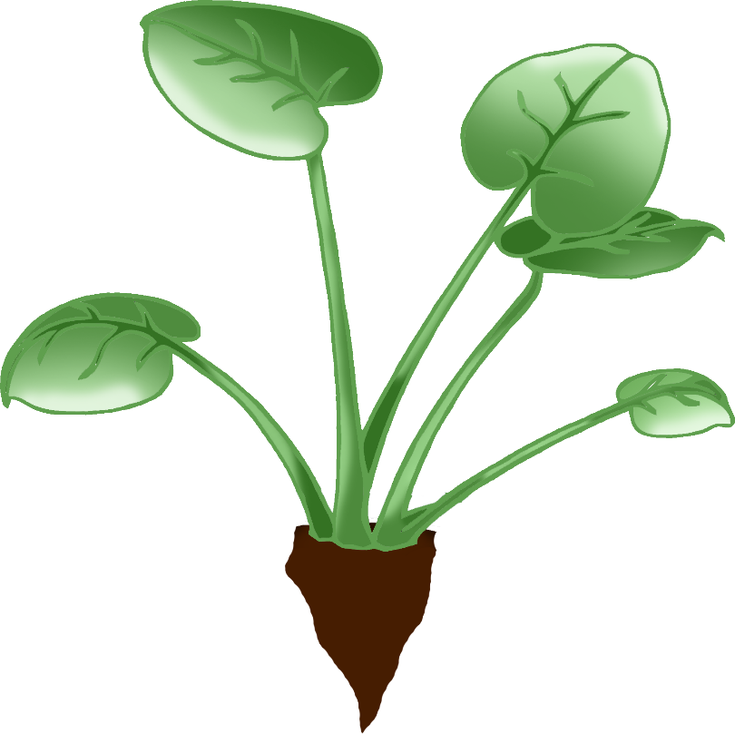

Water

Sunlight

Pot of soil