**Plants make…**

© 2022 Little Owls Resources

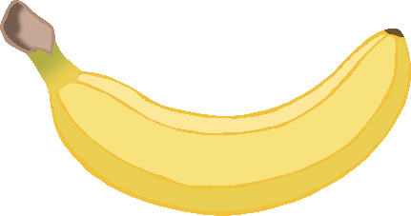

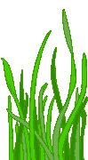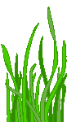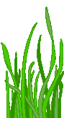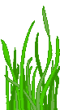

Animals (including humans) then eat plants as food.

…their own food

using

**sunlight!**