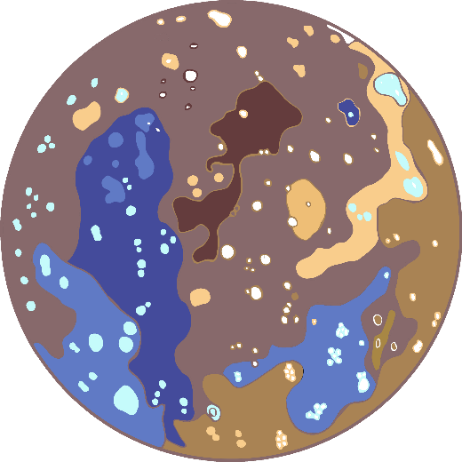

Mercury

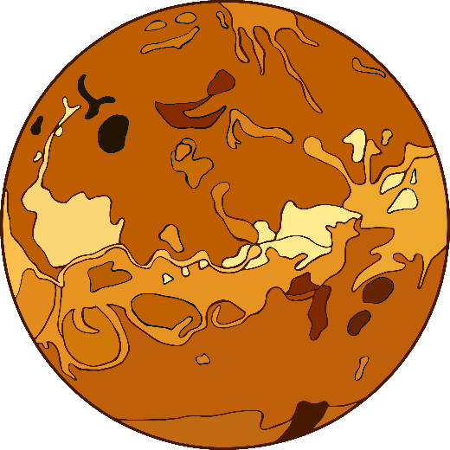

www.littleowls-premium.com

© 2020 Little Owls Resources

© 2020 Little Owls Resources

www.littleowls-premium.com

© 2020 Little Owls Resources

www.littleowls-premium.com

|  |  |
| --- | --- |
| Temperature: | 14˚C |
| A day lasts… | 24 hours |
| A year lasts… | 365 days |
| No. of moons: | 1 |

Earth

|  |  |
| --- | --- |
| Temperature: | 480˚C |
| A day lasts… | 5832 hours |
| A year lasts… | 224 days |
| No. of moons: | 0 |

Venus

|  |  |
| --- | --- |
| Temperature: | -183˚C (dark side) |
| 427˚C (light side) |
| A day lasts… | 1416 hours |
| A year lasts… | 88 days |
| No. of moons: | 0 |

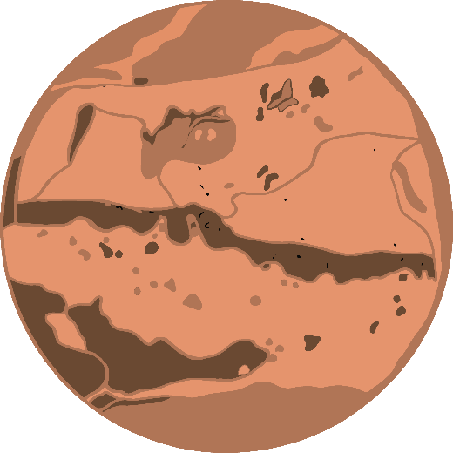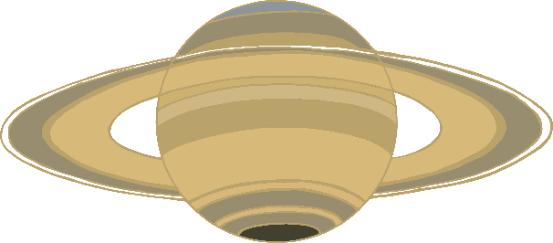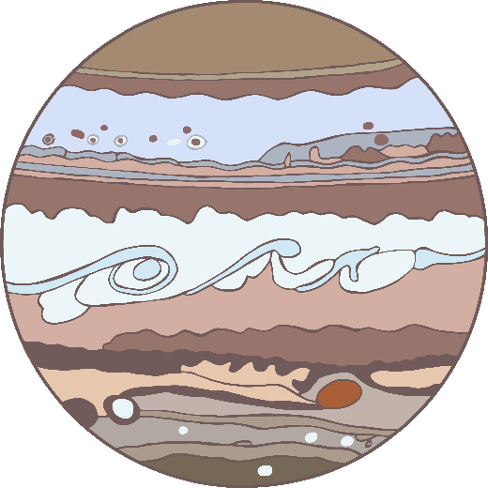

www.littleowls-premium.com

© 2020 Little Owls Resources

|  |  |
| --- | --- |
| Temperature: | -130˚C |
| A day lasts… | 10 hours |
| A year lasts… | 10585 days  (29 Earth Years) |
| No. of moons: | 62 |

www.littleowls-premium.com

© 2020 Little Owls Resources

|  |  |
| --- | --- |
| Temperature: | -130˚C |
| A day lasts… | 10 hours |
| A year lasts… | 4329 days  (11.8 Earth Years) |
| No. of moons: | 66 |

www.littleowls-premium.com

© 2020 Little Owls Resources

Saturn

Jupiter

|  |  |
| --- | --- |
| Temperature: | -63˚C |
| A day lasts… | 24 hours |
| A year lasts… | 687 days |
| No. of moons: | 2 |

Mars



Uranus

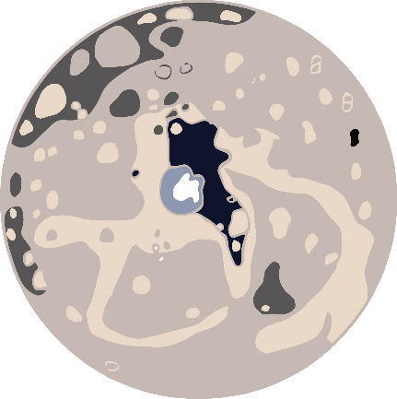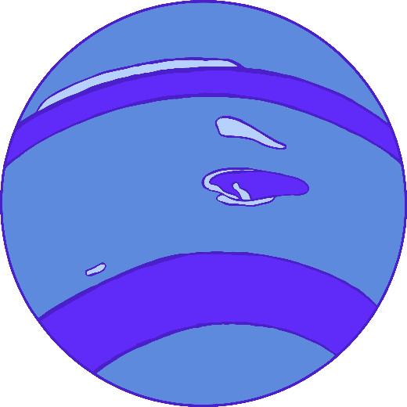

www.littleowls-premium.com

© 2020 Little Owls Resources

www.littleowls-premium.com

© 2020 Little Owls Resources

|  |  |
| --- | --- |
| Temperature: | -200˚C |
| A day lasts… | 16 hours |
| A year lasts… | 60225 days  (165 Earth Years) |
| No. of moons: | 14 |

www.littleowls-premium.com

© 2020 Little Owls Resources

|  |  |
| --- | --- |
| Temperature: | -200˚C |
| A day lasts… | 17 hours |
| A year lasts… | 30660 days  (84 Earth Years) |
| No. of moons: | 27 |

(Dwarf Planet)

Ceres

|  |  |
| --- | --- |
| Temperature: | -106˚C |
| A day lasts… | 9 hours |
| A year lasts… | 1680 days  (4.5 Earth Years) |
| No. of moons: | 0 |

Neptune

Pluto

(Dwarf Planet)

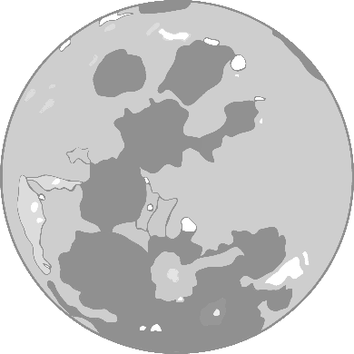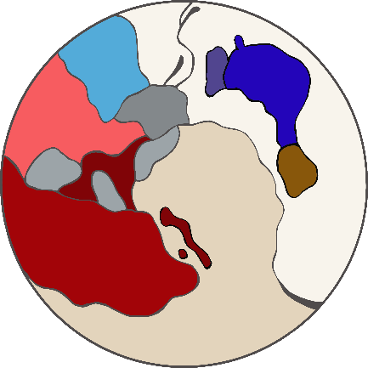

© 2020 Little Owls Resources

www.littleowls-premium.com

© 2020 Little Owls Resources

www.littleowls-premium.com

|  |  |
| --- | --- |
| Temperature: | -228˚C |
| A day lasts… | 153 hours |
| A year lasts… | 905200 days  (248 Earth Years) |
| No. of moons: | 5 |

* Temperature ranges from -233˚C to 123˚C
* No atmosphere/air at all
* You would feel six times lighter on the moon
* The moon affects the tides of the Earth’s oceans

|  |  |
| --- | --- |
|  |  |
|  |  |

The Moon

|  |  |
| --- | --- |
|  |  |
|  |  |

|  |  |
| --- | --- |
|  |  |
|  |  |

|  |  |
| --- | --- |
|  |  |
|  |  |

|  |  |
| --- | --- |
|  |  |
|  |  |

|  |  |
| --- | --- |
|  |  |
|  |  |

|  |  |
| --- | --- |
|  |  |
|  |  |