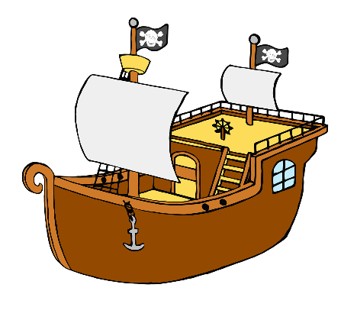

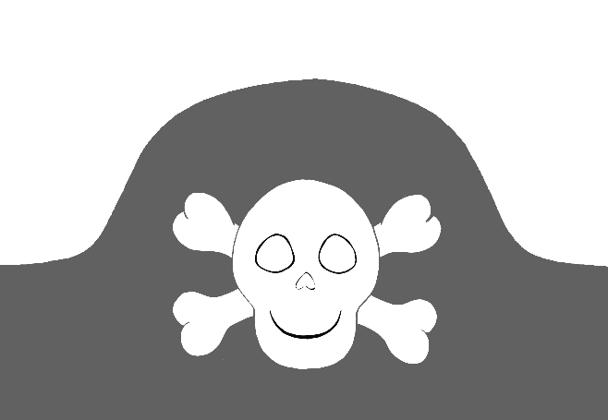

desert island

pirate ship

© 2021 Little Owls Resources

© 2021 Little Owls Resources

pirate hat

© 2021 Little Owls Resources

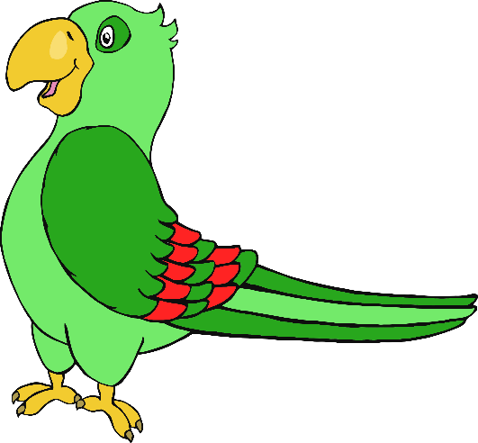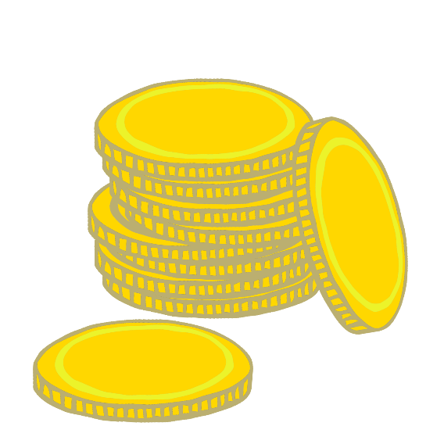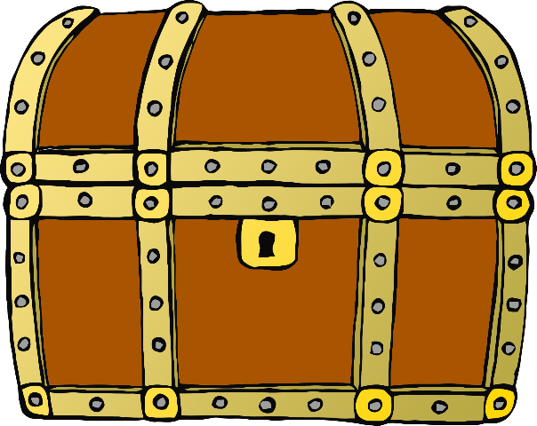

gold doubloons

treasure chest

parrot

© 2021 Little Owls Resources

© 2021 Little Owls Resources

© 2021 Little Owls Resources

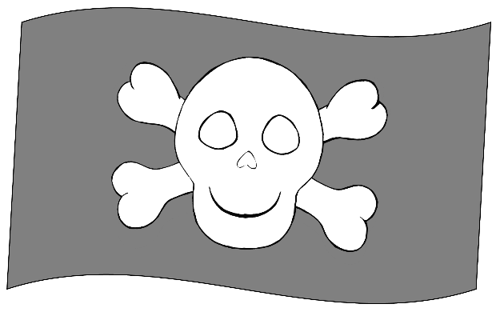

compass

pirate flag

telescope

© 2021 Little Owls Resources

© 2021 Little Owls Resources

© 2021 Little Owls Resources

map

© 2019 Little Owls Resources