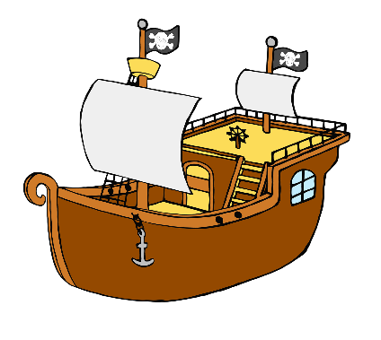

**Pirates Word Mat**

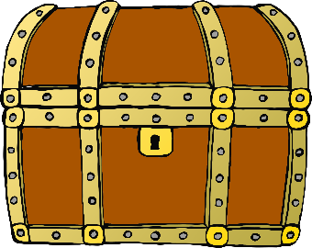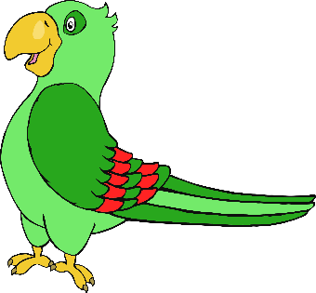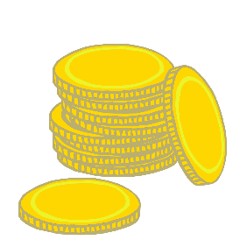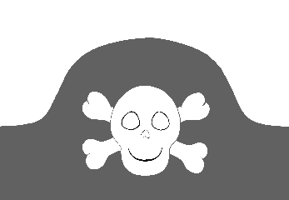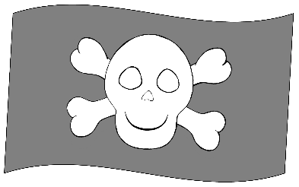

telescope

gold doubloons

parrot

treasure chest

desert island

pirate hat

pirate ship

map

compass

Jolly Roger flag

© 2021 Little Owls Resources