**Pirate Activity**

**Challenge!**

**1**

Count out your gold doubloons!

**1… 2… 3…**

**2**

Flap your arms and fly like a parrot!

Flap! Flap! Flap!

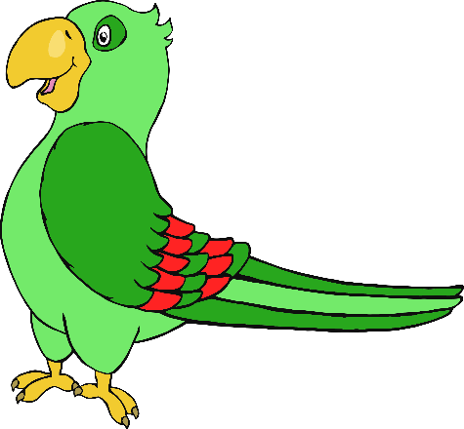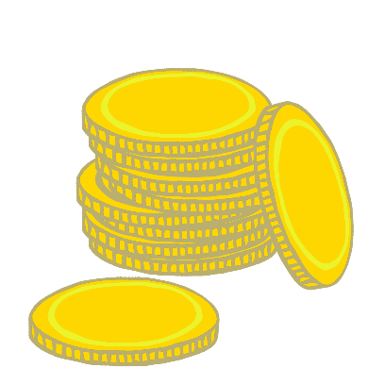

**Pirate Activity**

**Challenge!**

© 2021 Little Owls Resources

© 2021 Little Owls Resources

**3**

Swing your arm and shout like a pirate!

**Aaaaargh!**

**4**

Walk around on your wooden leg!

**Step! Bump! Step! Bump!**

**Pirate Activity**

**Challenge!**

**Pirate Activity**

**Challenge!**

© 2021 Little Owls Resources

© 2021 Little Owls Resources

**5**

Walk the plank!

**Step! Step!**

**Splash!**

**6**

Point to the desert island!

**Land Ahoy!**

© 2021 Little Owls Resources

© 2021 Little Owls Resources

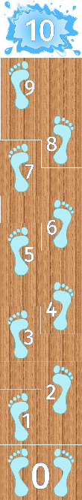

**Pirate Activity**

**Challenge!**

**Pirate Activity**

**Challenge!**

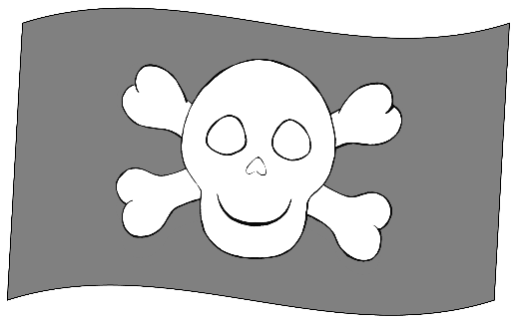

**7**

The ship is rocking on the waves!

Left! Right!

**8**

Pull the rope to raise the flag!

**Pull! Pull!**

© 2021 Little Owls Resources

© 2021 Little Owls Resources

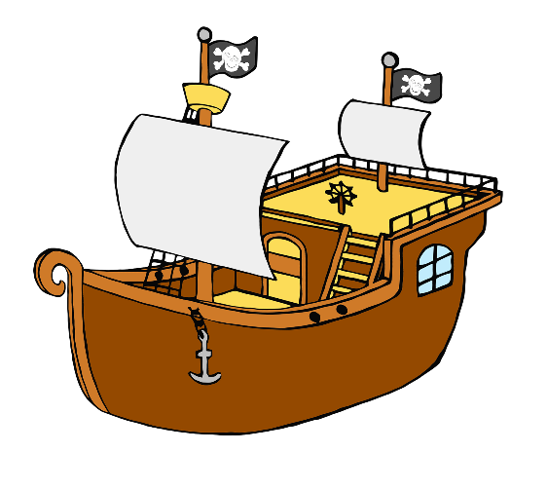

**Pirate Activity**

**Challenge!**

**Pirate Activity**

**Challenge!**

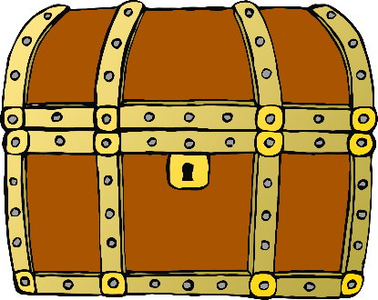

**Pirate Activity**

**Challenge!**

**Pirate Activity**

**Challenge!**

**9**

When you see the treasure your eyes go…

**W I D E!**

**10**

The sand is hot! Hop from foot to foot!

**Hop! Hop!**

© 2021 Little Owls Resources

© 2021 Little Owls Resources