**Pirate Treasure Hunt**

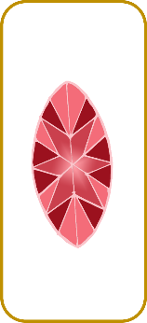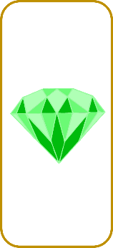

Have fun!!

Blank Pirate Treasure Hunt clues to be filled in before the game. Each clue to be placed with a treasure card for children to collect.

Using positional language (on, in, under, behind, etc) to describe the position of the next treasure to the children.

Encourage the children to follow your instructions to ultimately find the Treasure Chest!

under the red table

next to the bookcase

**Pirate Treasure Hunt**

The first treasure is…

© 2020 Little Owls Resources

**Pirate Treasure Hunt**

To start, the first treasure is…

© 2020 Little Owls Resources



**Pirate Treasure Hunt**

You will find the next treasure …

© 2020 Little Owls Resources

**Pirate Treasure Hunt**

Look for the next treasure …

© 2020 Little Owls Resources



**Pirate Treasure Hunt**

The next treasure is…

© 2020 Little Owls Resources

**Pirate Treasure Hunt**

The next treasure is…

© 2020 Little Owls Resources



**Pirate Treasure Hunt**

The final treasure is…

© 2020 Little Owls Resources

**Pirate Treasure Hunt**

Finally, look…

© 2020 Little Owls Resources



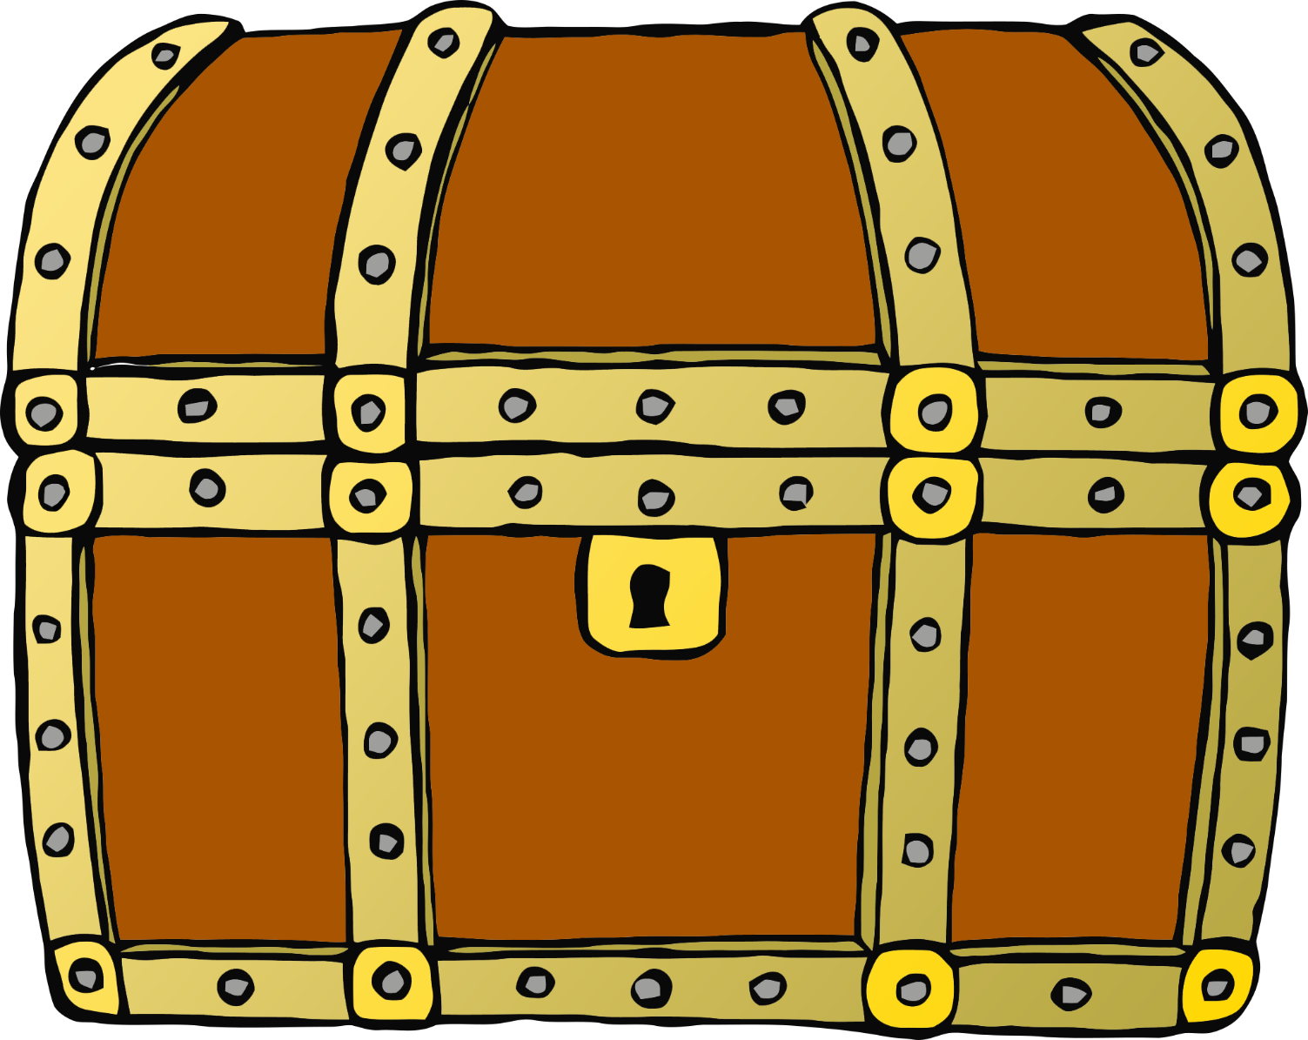



© 2020 Little Owls Resources

© 2020 Little Owls Resources

© 2020 Little Owls Resources

© 2020 Little Owls Resources

© 2020 Little Owls Resources

© 2020 Little Owls Resources

© 2020 Little Owls Resources

© 2020 Little Owls Resources

© 2020 Little Owls Resources

© 2020 Little Owls Resources

© 2020 Little Owls Resources

© 2020 Little Owls Resources

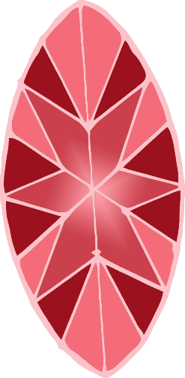

© 2020 Little Owls Resources

© 2020 Little Owls Resources

© 2020 Little Owls Resources

© 2020 Little Owls Resources

© 2020 Little Owls Resources

© 2020 Little Owls Resources



© 2020 Little Owls Resources

© 2020 Little Owls Resources

© 2020 Little Owls Resources

© 2020 Little Owls Resources

© 2020 Little Owls Resources

© 2020 Little Owls Resources

© 2020 Little Owls Resources

© 2020 Little Owls Resources

© 2020 Little Owls Resources

© 2020 Little Owls Resources

© 2020 Little Owls Resources

© 2020 Little Owls Resources