**Pirate Talk and Count**

Fold along here

*Game for two children.*

Organise the cards into two identical sets. 12 in each pile.

Child A to have a shuffled pile face-down in front of them.

The second set of 12 cards to be laid out with the gems showing in front of Child B.

Child A takes a card from the pile and looks at the picture. Then asks for the shown gems in their best pirate voice!

e.g. “Arrrr! Can I have two green gems matey?”

Child B to find the correct matching card to give to Child A.

When all cards are matched, reset the game, and reverse the roles!

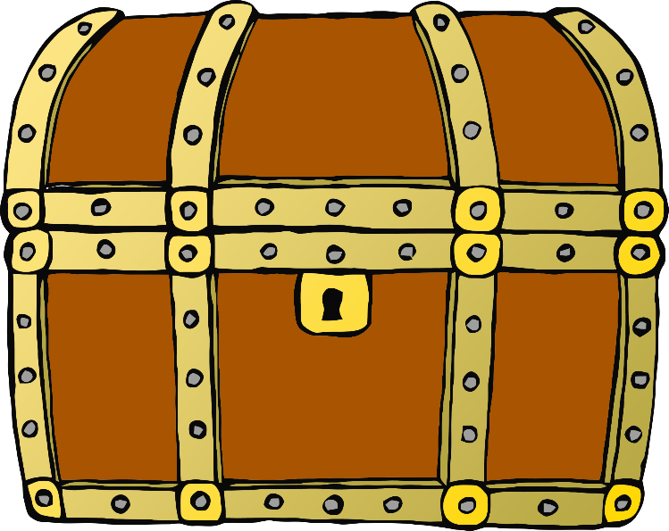

© 2020 Little Owls Resources



© 2020 Little Owls Resources



© 2020 Little Owls Resources



© 2020 Little Owls Resources



© 2020 Little Owls Resources



© 2020 Little Owls Resources



© 2020 Little Owls Resources



© 2020 Little Owls Resources



© 2020 Little Owls Resources



© 2020 Little Owls Resources



© 2020 Little Owls Resources



© 2020 Little Owls Resources



© 2020 Little Owls Resources



© 2020 Little Owls Resources



© 2020 Little Owls Resources



© 2020 Little Owls Resources



© 2020 Little Owls Resources



© 2020 Little Owls Resources



© 2020 Little Owls Resources



© 2020 Little Owls Resources



© 2020 Little Owls Resources



© 2020 Little Owls Resources



© 2020 Little Owls Resources



© 2020 Little Owls Resources