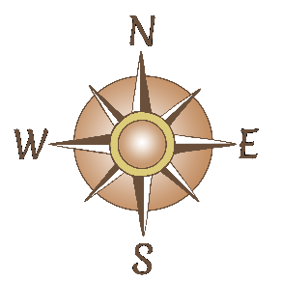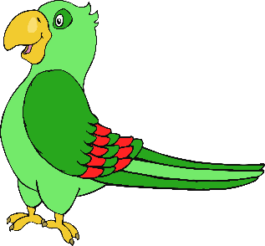

Written by: Unknown

**The Pirate Song**

**(The day I went to sea)**

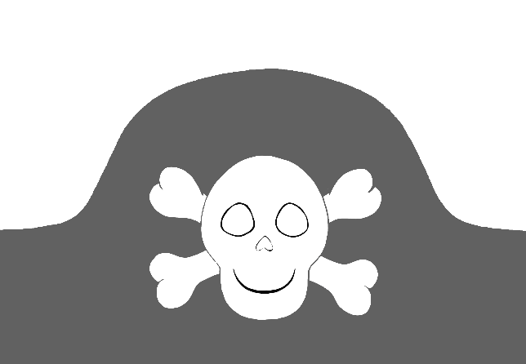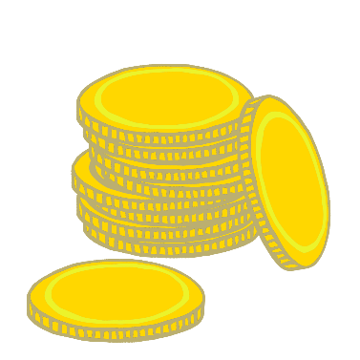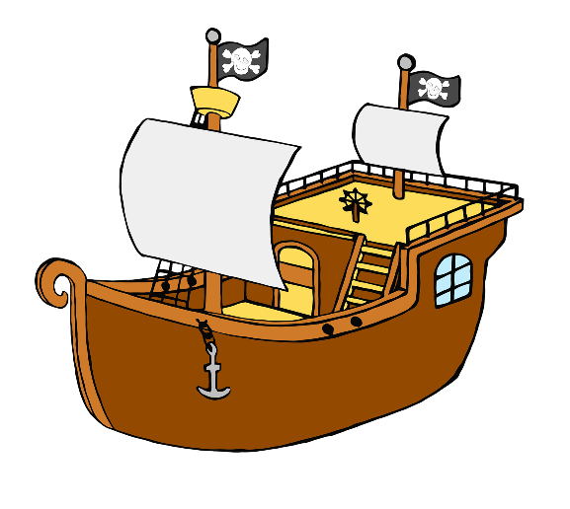

© 2021 Little Owls Resources

When I was one, I sucked my thumb,  
The day I went to sea.  
I climbed aboard a pirate ship  
And the Captain said to me:  
‘We’re going this way, that way,  
Forwards backwards,  
Over the Irish Sea.  
A bottle of rum to fill my tum  
A Pirates’ life for me’.  
  
When I was two, I buckled my shoe,  
The day I went to sea.  
I climbed aboard a pirate ship  
And the Captain said to me:  
‘We’re going this way, that way,  
Forwards backwards,  
Over the Irish Sea.  
A bottle of rum to fill my tum  
A Pirate’s life for me’.  
  
When I was three, I grazed my knee,   
The day I went to sea.  
I climbed aboard a pirate ship  
And the Captain said to me:  
‘We’re going this way, that way,  
Forwards backwards,  
Over the Irish Sea.  
A bottle of rum to fill my tum  
A Pirate’s life for me’.

When I was four, I swam ashore,  
The day I went to sea.  
I climbed aboard a pirate ship  
And the Captain said to me:  
‘We’re going this way, that way,  
Forwards backwards,  
Over the Irish Sea.  
A bottle of rum to fill my tum  
A Pirate’s life for me’.

When I was five, I learned to dive,   
The day I went to sea.  
I climbed aboard a pirate ship  
And the Captain said to me:  
‘We’re going this way, that way,  
Forwards backwards,  
Over the Irish Sea.  
A bottle of rum to fill my tum  
A Pirate’s life for me’.

When I was six, I gathered sticks,  
The day I went to sea.  
I climbed aboard a pirate ship  
And the Captain said to me:  
‘We’re going this way, that way,  
Forwards backwards,  
Over the Irish Sea.  
A bottle of rum to fill my tum  
A Pirate’s life for me’.

© 2021 Little Owls Resources

© 2021 Little Owls Resources

When I was seven, I went to Devon,  
The day I went to sea.  
I climbed aboard a pirate ship  
And the Captain said to me:  
‘We’re going this way, that way,  
Forwards backwards,  
Over the Irish Sea.  
A bottle of rum to fill my tum  
A Pirate’s life for me’.  
  
When I was eight, I was almost late  
The day I went to sea.  
I climbed aboard a pirate ship  
And the Captain said to me:  
‘We’re going this way, that way,  
Forwards backwards,  
Over the Irish Sea.  
A bottle of rum to fill my tum  
A Pirate’s life for me’.  
  
When I was nine, I was feeling fine,  
The day I went to sea.  
I climbed aboard a pirate ship  
And the Captain said to me:  
‘We’re going this way, that way,  
Forwards backwards,  
Over the Irish Sea.  
A bottle of rum to fill my tum  
A Pirate’s life for me’.  
  
When I was ten, I started again,   
The day I went to sea.  
I climbed aboard a pirate ship  
And the Captain said to me:  
‘We’re going this way, that way,  
Forwards backwards,  
Over the Irish Sea.  
A bottle of rum to fill my tum  
A Pirate’s life for me’.