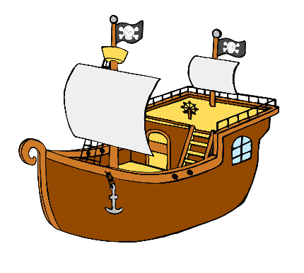

**Pirate Ship Names**

* Cut and laminate these names and place face down in a green pile and a red pile.
* Pick from the green pile for the first part of the ship name.
* Pick from the red pile for the second part of the ship name.

© 2021 Little Owls Resources

Mermaid’s

Dragon’s

Silent

Captain’s

Poisonous

Fiery

Ghost

Shadow

Darkness

Revenge

Curse

Dagger