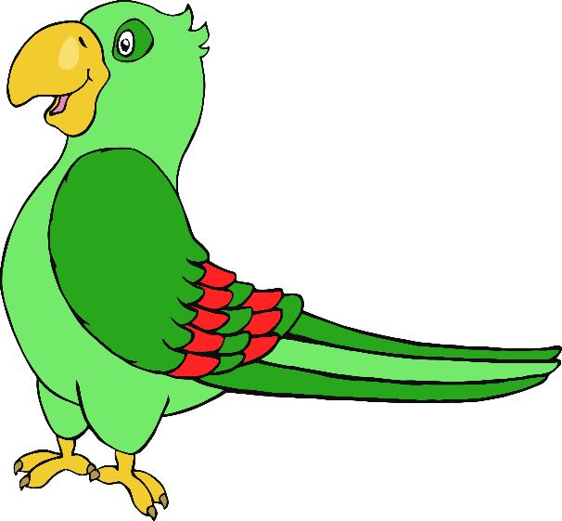

© 2020 Little Owls Resources

© 2020 Little Owls Resources

© 2020 Little Owls Resources

© 2020 Little Owls Resources

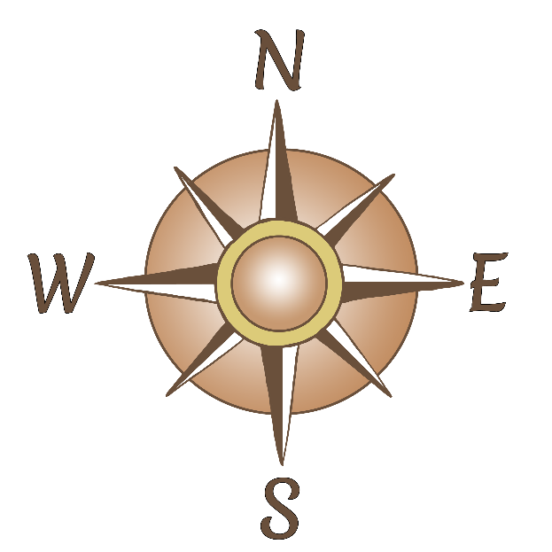

© 2020 Little Owls Resources

© 2020 Little Owls Resources

© 2020 Little Owls Resources

© 2020 Little Owls Resources

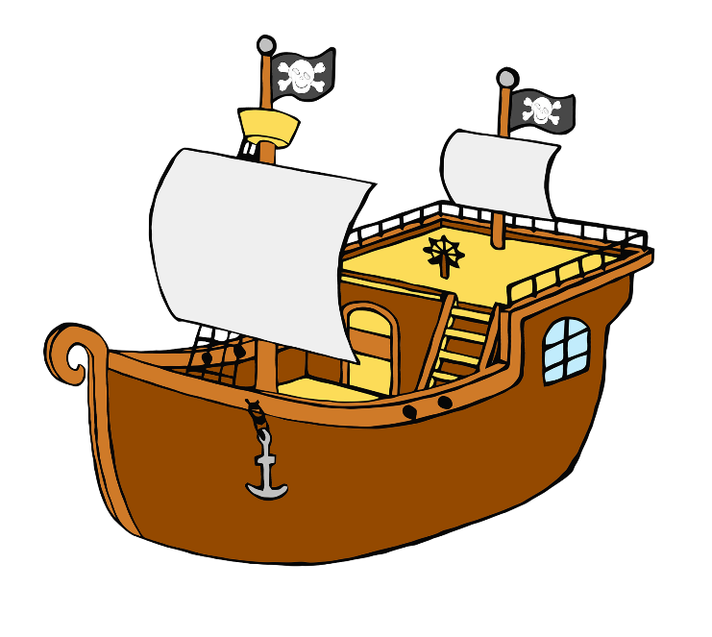

© 2020 Little Owls Resources

© 2020 Little Owls Resources

© 2020 Little Owls Resources

© 2020 Little Owls Resources

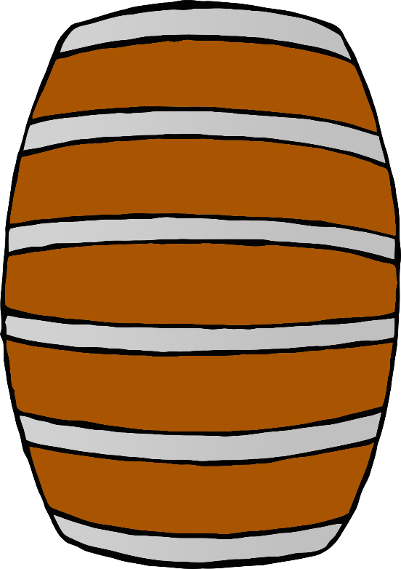

© 2020 Little Owls Resources

© 2020 Little Owls Resources

© 2020 Little Owls Resources

© 2020 Little Owls Resources



© 2020 Little Owls Resources

© 2020 Little Owls Resources

© 2020 Little Owls Resources

© 2020 Little Owls Resources



© 2020 Little Owls Resources

© 2020 Little Owls Resources

© 2020 Little Owls Resources

© 2020 Little Owls Resources

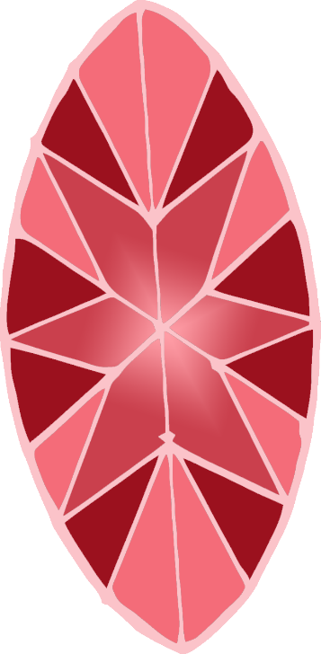

© 2020 Little Owls Resources

© 2020 Little Owls Resources

© 2020 Little Owls Resources

© 2020 Little Owls Resources



© 2020 Little Owls Resources

© 2020 Little Owls Resources

© 2020 Little Owls Resources

© 2020 Little Owls Resources

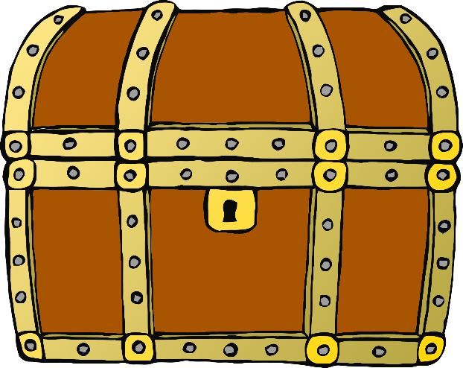

© 2020 Little Owls Resources

© 2020 Little Owls Resources

Resources

© 2020 Little Owls Resources

© 2020 Little Owls Resources

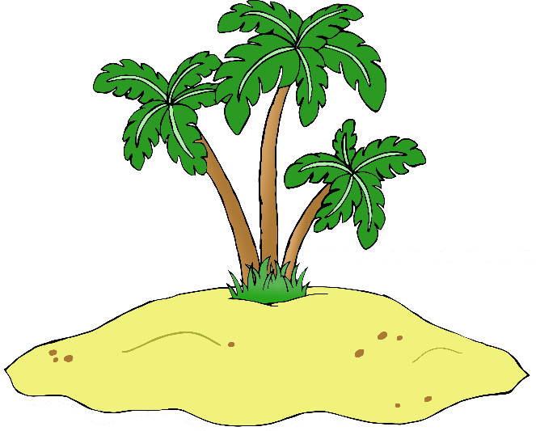

© 2020 Little Owls Resources

© 2020 Little Owls Resources

© 2020 Little Owls Resources

© 2020 Little Owls Resources

© 2021 Little Owls Resources

© 2021 Little Owls Resources

© 2021 Little Owls Resources

© 2021 Little Owls Resources

Resources