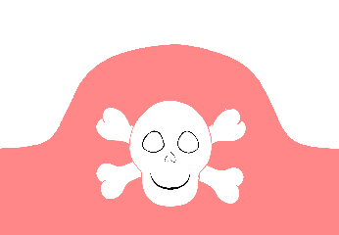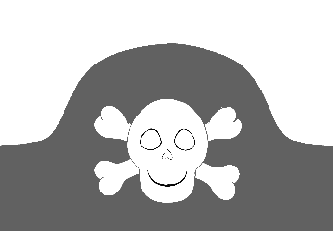

© 2020 Little Owls Resources

Pirate Hat Templates

Cut one half of the hat from this page, the other half from the next and then sellotape or staple the ends together. Colour/Design as you wish!

(Blank Templates on pages 3&4.)



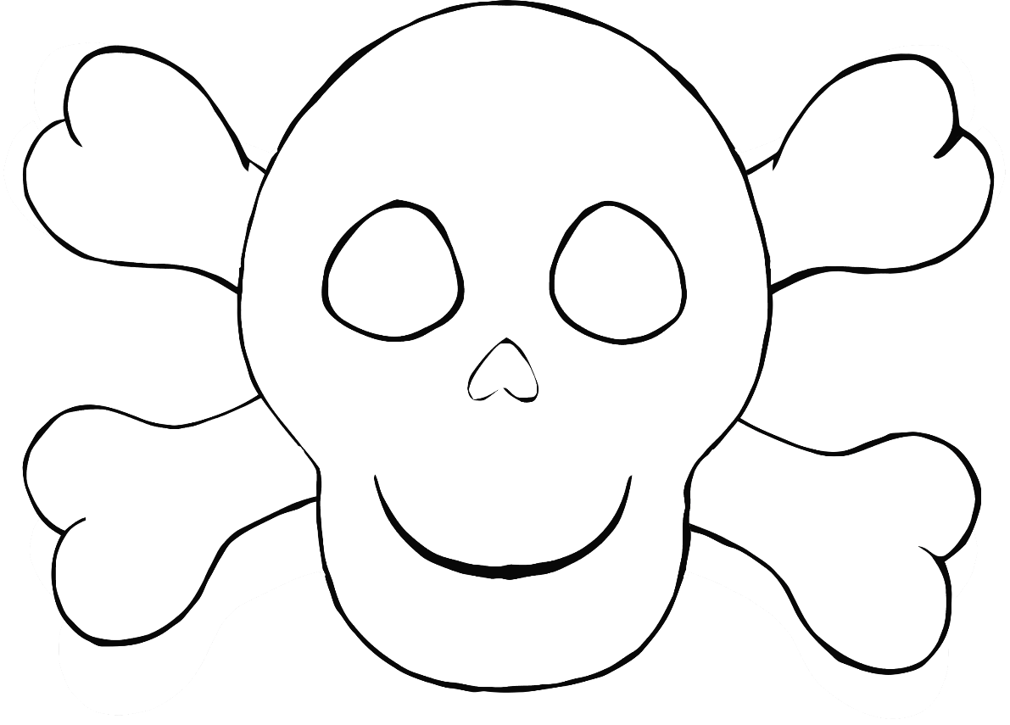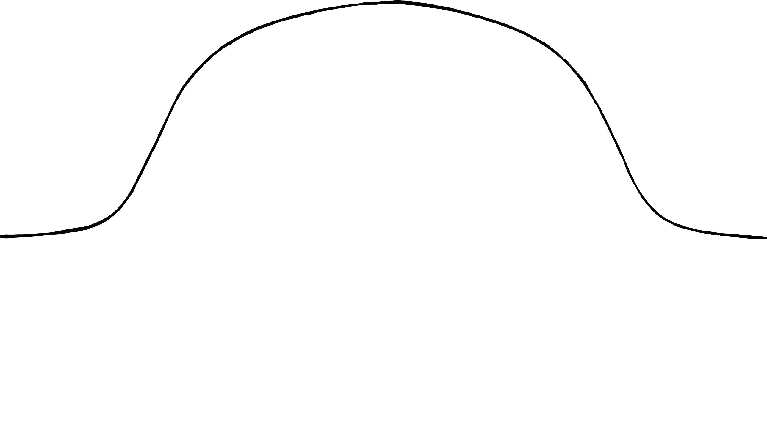



© 2020 Little Owls Resources

© 2020 Little Owls Resources

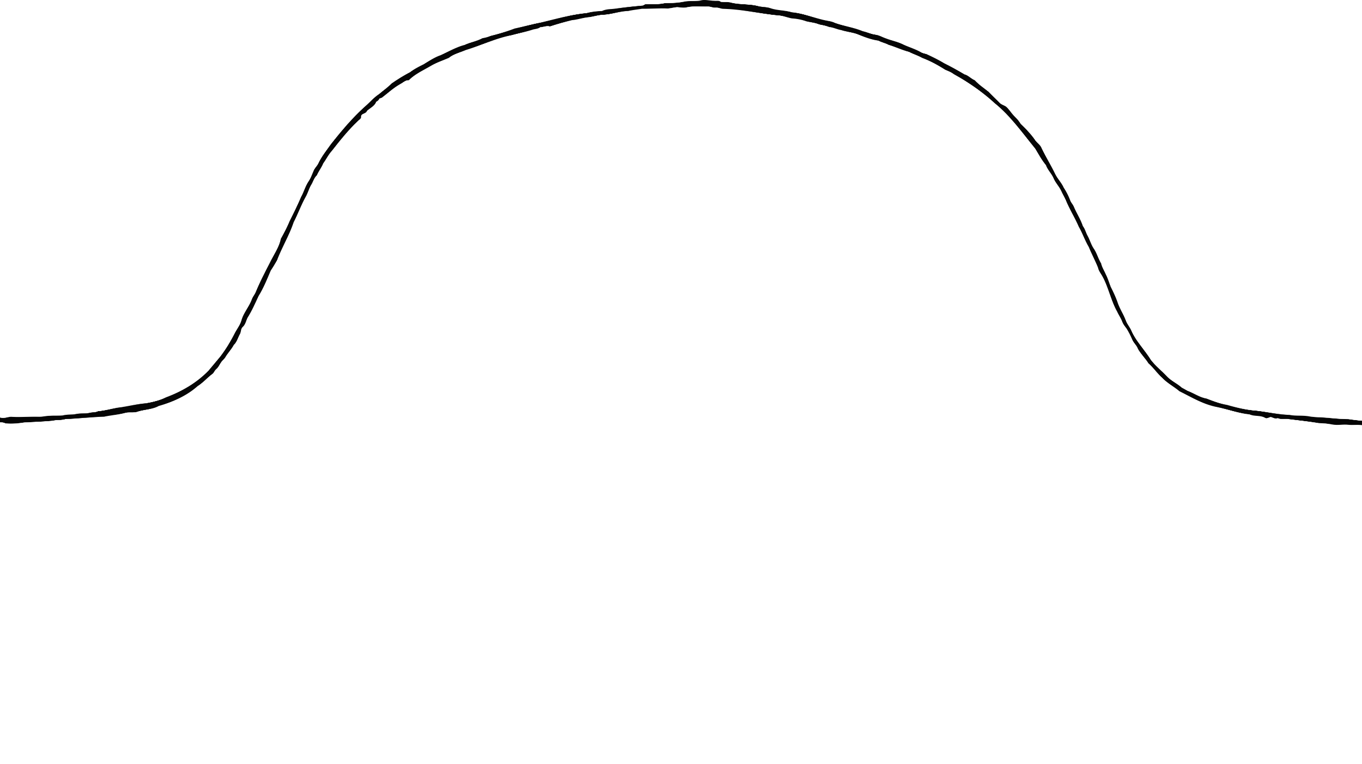



© 2020 Little Owls Resources