Pirate name:

**Pirate Character Sheet**

What do they do for fun?

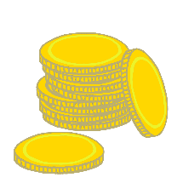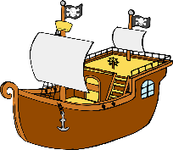

© 2021 Little Owls Resources

Pirate name:

**Pirate Character Sheet**

What do they do for fun?



© 2021 Little Owls Resources

Pirate name:

**Pirate Character Sheet**

What do they do for fun?



© 2021 Little Owls Resources

Pirate name:

**Pirate Character Sheet**

What do they do for fun?



© 2021 Little Owls Resources

Name:

Age:

What do they like to eat?

What do they like to drink?

What do they do for fun?

Special ability:

**Pirate Character Sheet**

© 2021 Little Owls Resources

Name:

Age:

What do they like to eat?

What do they like to drink?

What do they do for fun?

Special ability:

**Pirate Character Sheet**

© 2021 Little Owls Resources

Name:

Age:

What do they like to eat?

What do they like to drink?

What do they do for fun?

Special ability:

**Pirate Character Sheet**

© 2021 Little Owls Resources

Name:

Age:

What do they like to eat?

What do they like to drink?

What do they do for fun?

Special ability:

**Pirate Character Sheet**

© 2021 Little Owls Resources