Pirate Map CVC Word Builder Game

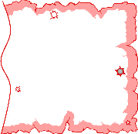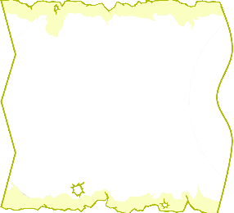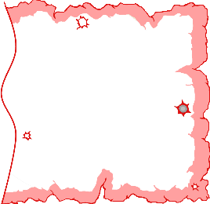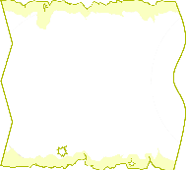

1. Pick a letter from the **green** pile as the **first** letter.
2. Next pick a vowel from the **yellow** pile as the **middle** letter.
3. Finally pick a letter from the **red** pile as the **final** letter.
4. Say the sounds of each letter. Try blending the letters together to read the word.
5. Is it a real word? Is it a nonsense word?

© 2021 Little Owls Resources

g

t

a

g

t

t

t

a

a

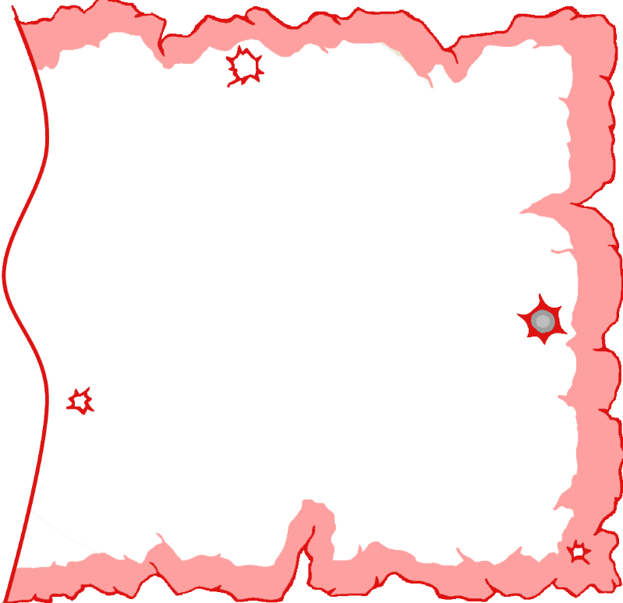

ss

s

t

t

p

p

n

n

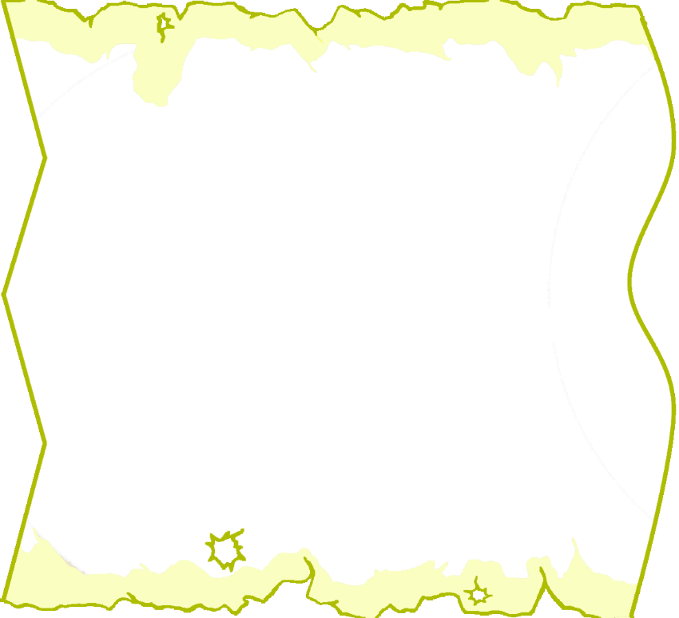

e

a

a

e





o

i

o

i



u

u

m

m

d

d

g

g

l

c

ll

k

b

b

ff

f

h

r