© 2021 Little Owls Resources

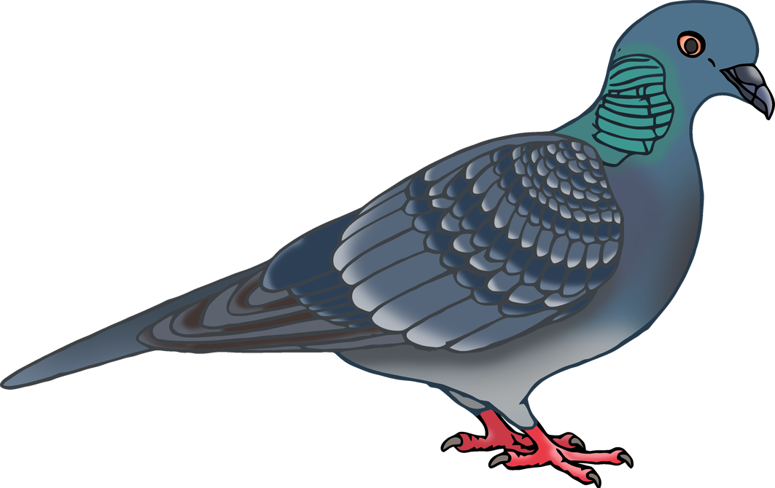

Pigeon body parts

h

f

b

t

**w**

© 2021 Little Owls Resources



Pigeon body parts

foot

tail

beak

head

**w**ing

© 2021 Little Owls Resources



Pigeon body parts