**Pig body parts**

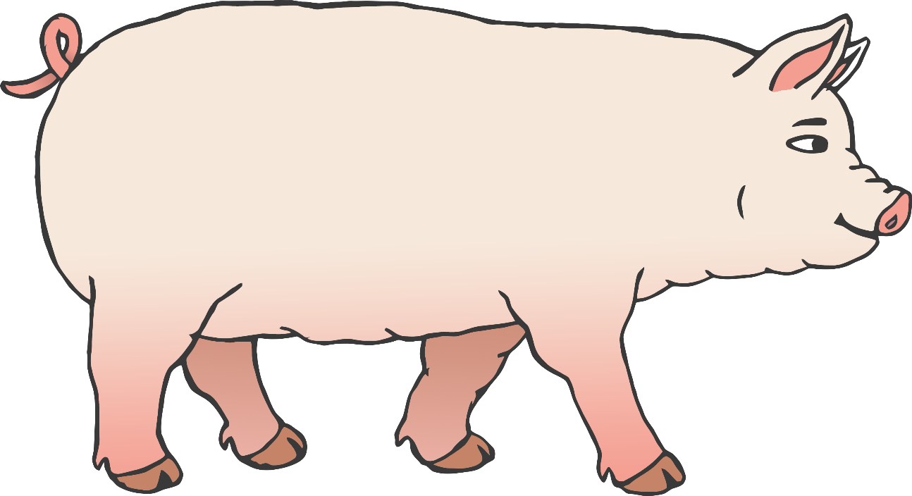

© 2021 Little Owls Resources



b

e

s

t

t

**Pig body parts**

© 2021 Little Owls Resources



back

ear

snout

trotter

tail

**Pig body parts**

© 2021 Little Owls Resources